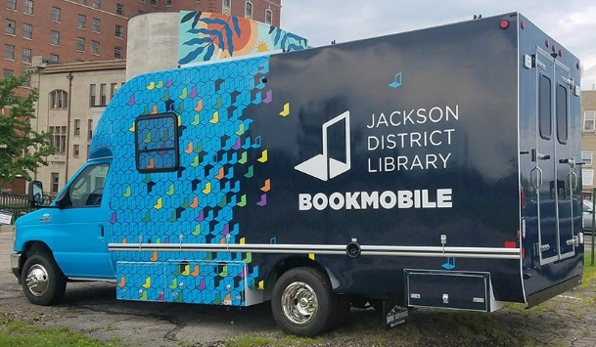May 20, 2024

Library Assistant II Bookmobile-Community Engagement

Full time 40hrs/week

You belong at JDL! Come join us and have the fun of driving the bookmobile around the county (it’s really not that big or intimidating) while meeting the people in our communities and serving them just like any other JDL branch. Training will be covered by JDL and you will be welcomed in to our team by the best people!

Our organization is dedicated to our diversity journey and believes it should be openly discussed and celebrated as we strive to create an open and safe space full of respect where everyone can bring their whole selves to work every day.

We are looking for a Bookmobile Library Assistant. In this role you will provide excellent customer service to our communities and patrons by performing traditional library services, you will also operate the bookmobile and travel to designated stops within the county.

JDL facilitates all training associated with driving and will incur any cost associated with obtaining a chauffeur license.

The ideal candidate will be an energetic and outgoing person who is passionate about bringing library services out into the community. This is the perfect job for someone who is excited about connecting with people, talking about books and other library materials, and bringing library services to those who need them most.

In addition, to thrive in this role you must be welcoming and hospitable and be able to assist with strengthening community connections through outreach and programming. Being a safe driver with a clean driving record is also a must as is the capability to review, communicate and adjust the bookmobile schedule.

In conversations with patrons and coworkers the Library Assistant II Bookmobile Operator is expected to be JDL’s biggest advocate. If you are a creative, friendly person who wants to work in a dynamic and innovative environment, we hope that you will consider joining our team!

Currently a typical **schedule** will look like Monday-Thursday: 11:30am-8pm and

Friday: 8:30-5.

(30-minute lunch each day). This is subject to change if needs change.

The **benefits** for this position include Health Insurance, Life Insurance, Pension, sick, vacation, personal business, and holiday time. In addition, JDL has an excellent Employee Assistance Program as well as tax deferred savings plan and Assurity voluntary insurance available.

**The successful candidate will have to successfully complete background check, license check, DOT physical and drug screen.**

Cover letter is appreciated.

**EOE**

24-017

Hours/week 40

Hourly rate 18.10

Closing date May 29, 2024