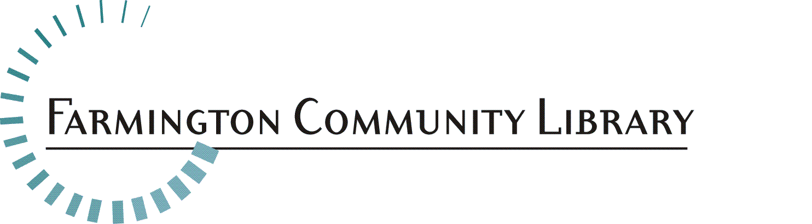

July 14, 2015

Position Available: Full-Time Early Childhood Specialist
Children’s Services Department

Applicants with a Bachelors Degree in Early Childhood Development or Bachelor’s Degree in Education with Early Childhood emphasis may apply.

Salary: $31,048-$52,345

Part-time Position: 40 hours per week

Fringe Benefits: Excellent

Deadline for Applications: July 27, 2015

Applicants who are selected for an interview will be contacted by phone or e-mail. Interviews will be held on August 12, 2015 at the Main Library.

Please include your resume, a completed application, www.farmlib.org/library/pdfs/fclemployentapp.pdf) and written answers to the following questions.

- How can the Farmington Community Library meet the needs of children from birth to age 5 to ensure Kindergarten readiness?

- In what ways can the Library become a hub of information and support for parents of children 0-5 years?

Please send your resume to: Elyse Streit, Library Director
Farmington Community Library
32737 West 12 Mile Road
Farmington Hills, MI 48334
elyse.streit@farmlib.org

Job Summary:

Under the supervision of Children’s Department Heads, the Early Childhood Specialist serves as the authority and staff resource on early childhood development and emergent literacy. The Early Childhood Specialist will provide public service to children, young adults and adults among other duties.

Essential Duties/Responsibilities:

Assists the Children’s Department Heads in developing and delivering programs and services to enhance child development and caregiver knowledge based on current best-practices in early childhood development and emergent literacy:
- Scheduled programs for ages 0-5 years
- Drop-in activities offered in the department during all hours of operation
- Children’s Outreach Services
- Scheduled educational programs for parents, caregivers, and/or teachers
- Production of educational materials for parents, adults, caregivers and teachers distributed in-house, at community agencies, online, and through the media

Provides welcoming public service at the Children’s Information Desk:
- Efficient and accurate reference and reader’s advisory services using print and electronic resources
- Patron instruction in learning to use the automated catalog and circulation system, public computers, the Internet and electronic resources
- Becomes knowledgeable of all print and digital Children’s collections
- Becomes familiar with all other print and digital collections

Manages assigned area(s) of collection with purchases, weeding and promotion.

Provides public, department and library-wide training on aspects of early childhood development and emergent literacy. Schedules speakers and trainers.

Cultivates partnerships with community organizations and agencies that serve families by scheduling their programs in the library, participating in their events, cross-promoting services/events and networking.

Assists in library promotion at general community events and Story Time visits as required.

Maintains membership in state or national library or early childhood organizations, attends conferences and reads professional literature.

Minimum Qualifications:
- Bachelor’s degree in Early Childhood Education or degree in education with emphasis on early childhood
- At least two years of recent paid work experience with children ages 0-5 years preferably in an educational or library environment
- Extensive knowledge of books and digital resources for ages 0-5 years
- Demonstrated knowledge and understanding of early childhood development, family engagement practices and emergent literacy
- Experience and expertise in programming, especially for parents, caregivers and children ages 0-5 years
- Ability to interact in a professional, courteous and tactful manner to establish and maintain effective relationships with staff and the public
- Critical thinking skills, as applied to successfully serving the public and working with colleagues
- Knowledge of literature, current events, and general information found helpful in resolving reference inquiries
- Effective oral and written communication skills
- Familiarity with current technology, i.e., general computer literacy, knowledge of the Internet, iPads and apps, and other electronic sources of information
- Demonstrated proficiency with Microsoft Word and PowerPoint
- Excellent understanding of public service values

Physical Activity Requirements:
[Degree of physical demands (strength) usually associated with the essential functions of the job]
Light Work: Exerting up to 20 pounds of force occasionally, and/or up to 10 pounds of force frequently, and/or a negligible amount of force constantly to move objects. Physical demand requirements are in excess of those for Sedentary Work. Light Work usually requires walking or standing to a significant degree. The type of physical demands usually associated with the essential functions of this classification are: stooping, kneeling, crouching, reaching overhead and horizontally, handling, fingering, feeling, talking, hearing, and seeing.

Equipment Commonly Associated with this Job:
Personal computer, printer, copy machine, scanner, fax, projector, and automated telephone system, among others.

