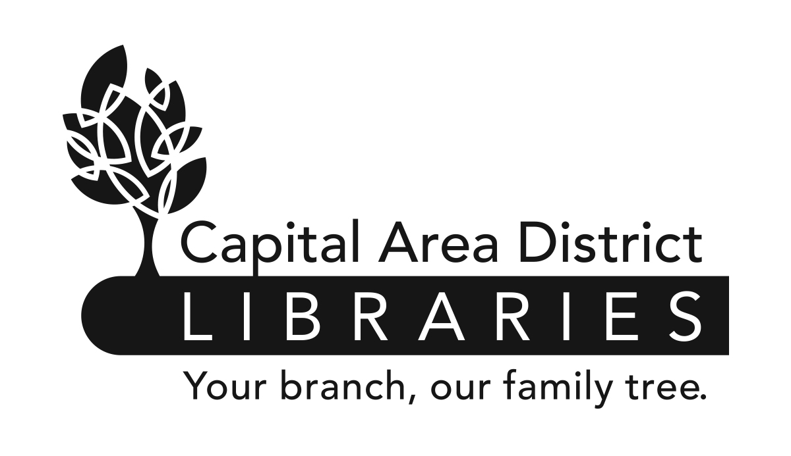

JOB ANNOUNCEMENT

CAPITAL AREA DISTRICT LIBRARIES

PO Box 40719, Lansing, MI 48901-7919 (517) 367-6300

DATE: November 1, 2013

POSITION: PUBLIC SERVICES LIBRARIAN

HOURS & DOWNTOWN BRANCH, 401 S. Capitol Avenue, Lansing, MI 48933
OF POSITION: 15 Hours/week. Will include evenings and weekends.
EMPLOYMENT:

Capital Area District Libraries (CADL) provides library services to our local communities seven days per week. All positions will require some evening and weekend hours, including Sundays. While this position is currently assigned at the above location, CADL reserves the right to require all employees to be available for assignments at any CADL location.

EDUCATION & Possession of a Master’s Degree in Library Science or its
EXPERIENCE: equivalent from an ALA accredited institution. Possession of a
Michigan Librarian’s Professional Certificate. This is an entry-level position; no previous experience is required. Second Language speakers desired (Spanish, Arabic, Vietnamese, Farsi, Hmong/Lao, and Serbo-Croatian).

NATURE OF Under the supervision of a Public Services Head, provides
WORK: reader’s advisory and reference assistance to patrons of all ages. Develops and maintains assigned library collections; provides one-on-one and group training for library patrons and staff; provides programming for youth and adults. Also performs professional work in reader’s advisory service, collection development, reference, acquisitions, or other specific fields. May supervise the work of support staff.

SALARY: $ 21.50/hour

DEADLINE TO Must be received by 5:00 p.m. Thursday, November 14, 2013.
APPLY:

FOR DETAILS Contact the Capital Area District Libraries, 401 S.
AND/OR Capitol Avenue, Lansing, Michigan, Monday-Friday,
APPLICATION: 9am-5pm, (517) 367-6300 or visit www.cadl.org/jobs

Please send a completed Capital Area District Libraries Application* to: Capital Area
District Libraries, Attn: Human Resources, PO Box 40719, Lansing, MI 48901-7919.

*All applications for employment must be made on the Capital Area District Libraries application form and completed in full. Resumes will not be accepted or evaluated in lieu of application. All applicants must meet the minimum and special eligibility requirements, as listed on this job announcement, for the vacancy and file a timely application in order to be considered. Separate application forms must be submitted for each position for which an applicant wishes to apply.

CAPITAL AREA DISTRICT LIBRARIES SYSTEM
IS AN EQUAL OPPORTUNITY EMPLOYER.

