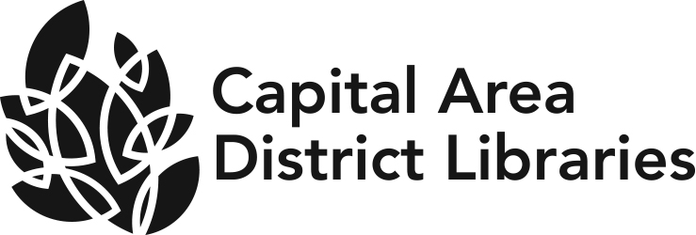
JOB ANNOUNCEMENT

DATE: July 28, 2022

POSITION: Public Services Head

HOURS &LOCATION Haslett Branch, 1590 Franklin Street, Haslett, MI 48864.
OF POSITION: This position is full time.

Join Capital Area District Libraries! CADL supports 13-branches and serves a population of over 240,000 residents located in Ingham County. We are looking for a creative, hardworking person who will help us advance the library’s mission of empowering diverse communities to learn, imagine and connect.

EDUCATION &EXPERIENCE: Possession of a Master's Degree in Library Science or its equivalent from an ALA accredited program.
Possession of a Michigan Librarian’s Professional Certificate.
A minimum of two years professional experience in a public library.
Supervisory experience preferred.
Experience working with children and teens

NATURE OF WORK: Under the supervision of the Library Head provides excellent, friendly and user centered services to community members. Provides day to day direction to staff members to develop a culture of continual improvement. Assists the Library Head in coordinating the activities of staff members, setting goals, assigning duties, and scheduling work hours.
Recommends best practices and procedures for adult and youth services and manages collections to optimize materials based on patron needs.

SALARY RANGE: $63,288 annually

BENEFITS: CADL offers full medical, dental, vision and retirement benefits
Paid time off includes vacation, sick, personal and holidays.

DEADLINE TO APPLY: Must be received by 5:00 p.m. August11, 2022.

We welcome new staff and the unique contributions each one brings to our library. We strive to hire a wide variety of people from diverse backgrounds to strengthen the service we provide the community. Our goal is to make everyone feel welcome and have a voice at Capital Area District Libraries.
CAPITAL AREA DISTRICT LIBRARIES SYSTEM IS AN EQUAL OPPORTUNITY EMPLOYER.

