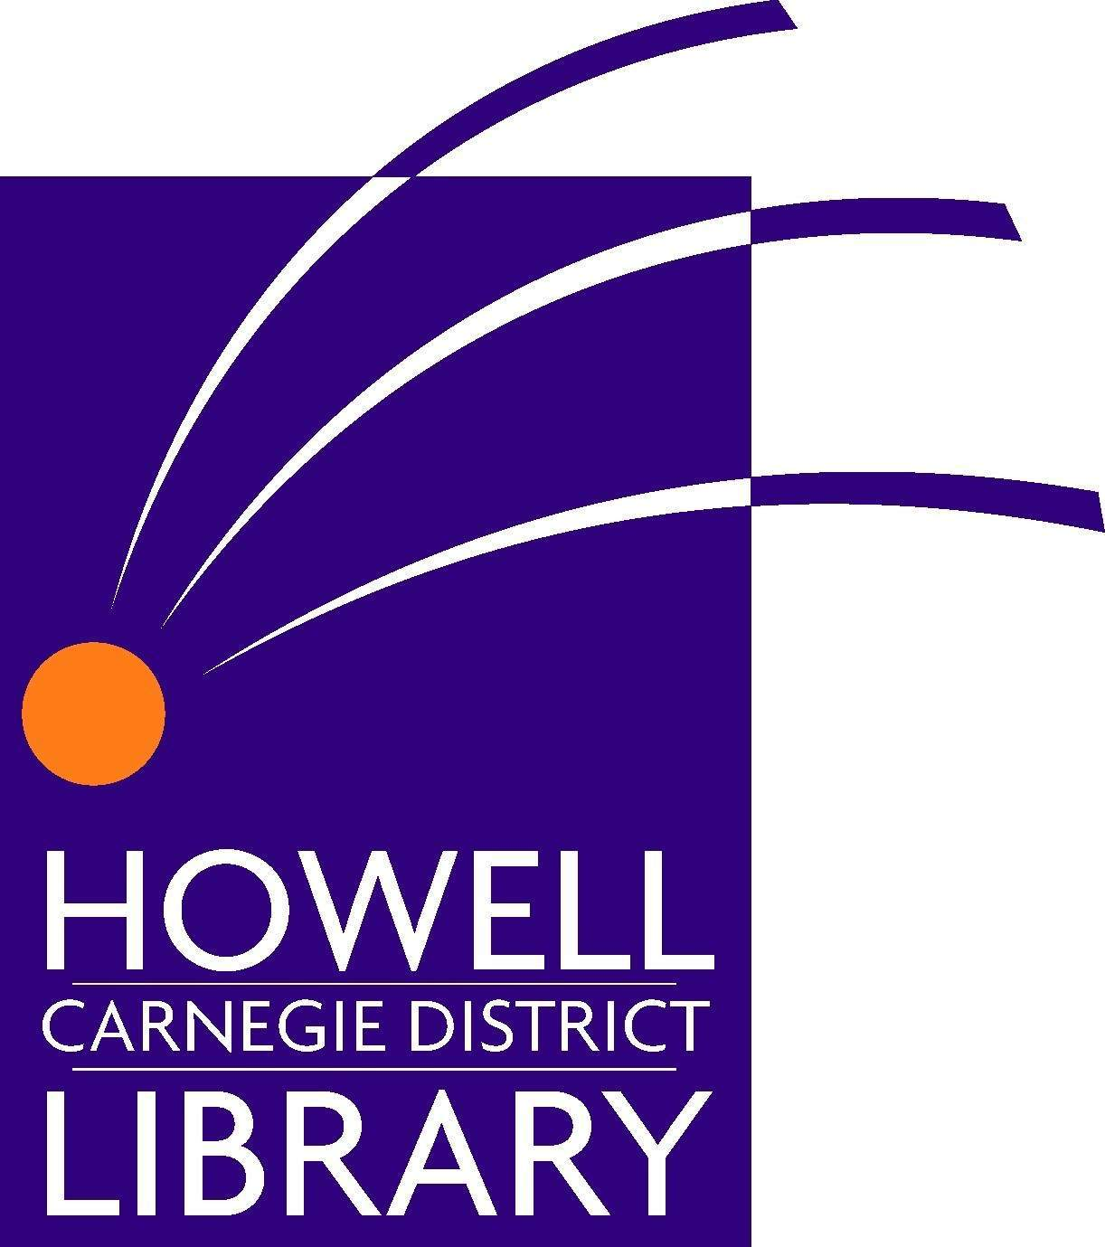
HEAD OF YOUTH SERVICES

The historic Howell Carnegie District Library (HCDL) has a full-time position available for an experienced, team-oriented Head of Youth Services to oversee the operation of the library’s Youth Services Department.

Qualifications Required:
- Completion of an ALA accredited MLS
- Minimum three years of professional library experience
- Minimum two years supervisory experience
- Enthusiastic, positive public service orientation

Qualifications Preferred:
- Awareness of children & teens current reading, viewing and listening interests and habits
- Proven ability to work collaboratively with outside organizations, including schools
- Demonstrated initiative and accountability

Duties:
- Supervise and oversee all operations of the library’s Youth Services Department
- Demonstrate and model excellent internal and external customer service
- Oversee all programming for youth and their caregivers
- Manage the allocation of resources for Youth Collection Development
- Responsible for Youth Services staff scheduling, training & development
- Work collaboratively with community organizations
- Some evenings and weekends required
- Represent HCDL in the community through community events and service organizations
- Actively participates in library planning and development
- Other duties as assigned

Wages:
$45,490 – $59,134 annual beginning salary depending on experience, with great benefit package available. The Howell Carnegie District Library is an equal opportunity employer.

Applications will be accepted until the position is filled, but those received by January 22, 2018 will receive first consideration. Interested individuals should forward a cover letter which specifically addresses the position requirements, a resume and three references with contact information, including email addresses.

Send resume to Howell Carnegie District Library, 314 W Grand River, Howell, MI 48843 or email to employment@howelllibrary.org. For more information call Diane McKee at 517-546-0720 x 114.

12-18-17

