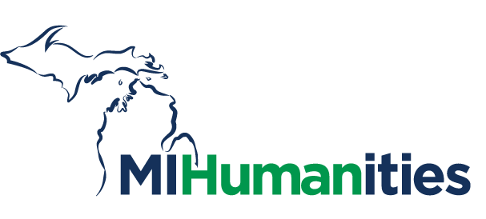
NEWS

2364 Woodlake Drive, Suite 100
Okemos, MI 48864
FOR IMMEDIATE RELEASE CONTACT: James Nelson
June 2, 2021 Phone: 517-372-7770
jnelson@mihumanities.org

Michigan Humanities Awards Over $220,000 for Cultural Programming
LANSING, MI—Michigan Humanities is pleased to announce $221,915 in grants to 17 organizations in support of public humanities programming. The 17 projects explore a range of humanities-topics and include exhibitions, community programming, filmmaking, speaker events, and storytelling.
“We are so pleased to announce the Spring Humanities Grants for 2021,” said Shelly Hendrick Kasprzycki, President & CEO. “The public humanities programs involved are exciting. We are pleased to have had more submissions than ever before and look forward to seeing the projects come to fruition.”
Humanities Grants award up to $15,000 per project to Michigan nonprofits doing work to support cultural, educational, and community-based public programming with a humanities element. These grants play a vital role in sharing our diverse culture, state, community, and identities, and are intended to connect us to Michigan’s rich cultural heritage and historical resources.
Spring 2021 project details can be found on the Michigan Humanities website at michiganhumanities.org/humanities-grants. The organizations with award amounts are listed below.

Spring 2021 Humanities Grant Awards
Affirmations LGBTQ Community Center—Intersectional Storytelling, $15,000

Black Bottom Archives—Black Bottom Street View, $14,800

Chaldean Cultural Center—Digital Storytelling of Chaldeans in Michigan, $15,000

Great Lakes Children’s Museum—Isn’t Everyone Like Me? I See YOU, $15,000

Hope College—Little Read Lakeshore 2021 – Fry Bread: A Native American Family Story, $15,000

iMichigan Productions—Flint Youth Film Festival, $15,000

Lowell Area Arts Council—WordView: Art Inspiring Art, $14,400

Michigan Quarterly Review—Decades of Fire: The Middle East and North Africa (A Special Issue of the Michigan Quarterly Review), $6,075

Michigan Technological University—Bad Information: Fake News, Manipulated Photographs, and Social Influencers, $8,350

Midtown Detroit, Inc.—DLECTRICITY – Lantern Landscapes: The Past Spread Out Before Us, $15,000

Prison Creative Arts Project—The Prison Creative Arts Project Writing Program, $8,275

Regents of the University of Michigan—Exploring Mideast Michigan’s Empty Spaces: A Traveler’s Guide, $15,000

The Arts League of Michigan (doing business as the Carr Center)—Jazz from Detroit, $15,000

Wayne State University—Celebrating the Past – Connecting the Future, $15,000

Western Michigan University Homer Stryker School of Medicine—The B.L.A.C.K. Project: Building Leaders and Champions of Knowledge, $14,000

Writers Series of Traverse City—Dr. Robin Wall Kimmerer: intertwining ecology, science, indigenous spirit, and story., $6,015

Youth Arts: Unlocked—Improv-ology, $15,000

###
About the Michigan Humanities
As one of 56 state (and territories) humanities councils in the country, Michigan Humanities was founded in 1974 as a result of federal legislation. Funded in part by the National Endowment for the Humanities, Michigan Humanities also actively seeks grants, sponsorships, and individual donations to further support cultural programming for Michigan communities.
Mission
To inspire us to come together in creative and freely expressed ways to deepen our understanding of ourselves and enrich our communities.
Vision
For all people of Michigan to experience and understand the importance of humanities to enrich lives.
Values
- Inclusion, Diversity, and Equity
- Discovery and Understanding
- Authentic Conversation
- Respectful Collaboration
- Meaningful Experiences

Pillars
- Build awareness and excitement for humanities in everyday life.
- Achieve best practices and sustainability for all humanities programs and services in Michigan.
For more information on future programs, upcoming grant opportunities or how you can support these efforts, please visit www.michiganhumanities.org or call (517) 372-7770.
###

