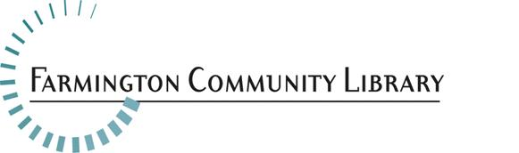

July 10, 2018

Position Available: Information Services Intern, Adult Services Department

Wage: $12.73 per hour with no benefits
Hours: 16-19 hours per week, including evening and weekend hours
Application Deadline: Thursday, July 19 by 5:00 p.m.
Please include your cover letter, resume, and application http://history.farmlib.org/pdfs/Employment_Application_3_2018.pdf to:
Diane Serresseque, Executive Assistant
32737 W Twelve Mile Road
Farmington Hills, MI 48334
Diane.Serresseque@farmlib.org
General Information
This position offers paid, practical library experience for students currently enrolled in a School of Information/Library Master’s program. Students are responsible for providing evidence of enrollment and satisfactory progress toward completion of their degree.
Essential Duties and Responsibilities
- Provides information, reference service and readers’ advisory service to patrons of all ages in person, over the phone, and via email
- Performs collection maintenance duties as assigned
- Develops, plans, implements, or assists with library programs for all ages as appropriate
- Attends meetings as appropriate
- Assists patrons on public computers
- Other tasks as assigned
Minimum Qualifications
- Current enrollment in a School of Information/Library Science Master’s program
- Successful and relevant work experience in a public service setting
- Ability to work successfully with diverse patrons of all ages, ethnicities and backgrounds
- Positive attitude and approach to problem-solving, customer service and public service
- Excellent communication and interpersonal skills
Preferred Qualifications
- Experience working in a public library
- Experience or class work in reference or research services

