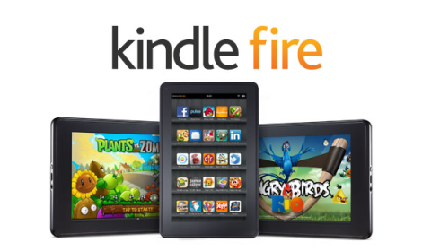
How to borrow titles from your library on OverDrive using a Kindle Fire

The OverDrive app is a great way to quickly find and get eBooks, audiobooks, streaming videos, and periodicals from your library or school.
Contents:
A) First Time Setup………………p1
B) Getting to the Ohio Digital Library Catalog………………p1
C) Signing In………………p2
D) Finding an Item in the Catalog………………p2
E) Checking Out an Item………………p3
F) Downloading an Item………………p4
G) Reading/Listening To/Watching an Item………………p4
H) Return an Item/Delete an Item………………p5
I) Placing a Hold/Checking Out a Hold………………p6
J) Renewing Items………………p7

First Time Setup
- Download the OverDrive app from you Kindle’s app store.
  - To get to your app store tap Apps at the top of your Kindle’s main screen, then tap Store in the top left-hand corner. Then search for “OverDrive”, tap the OverDrive icon, and then tap Download. Once the app opens you will be asked to sign up for (or sign into) your OverDrive account (if the app did not open, you can get to it by going to your Kindle’s home screen and tapping Apps at the top). You may follow the on-screen instructions to get an account, or if you do not want an OverDrive account, you may click “Continue” at the bottom instead. A benefit of having an OverDrive account is that if you read/listen to books on multiple devices, having an account will allow you to keep your place in the book between devices. If you do not have an account, OverDrive will keep the place you left off in your book only on the device in which you last read the book.
- Tap the menu icon in the top-left corner to open the Home menu to see your library list.
- If you do not see “Ohio Digital Library” at the top of the menu, click Add a Library. Then click the white search box, type Way Public Library, tap Way Public Library from the list, and then tap the star next to “Ohio Digital Library” to make the star turn yellow to finalize the process to add our catalog to your library list. Then tap Ohio Digital Library.

Getting to the Ohio Digital Library Catalog

If you just finished the “First Time Setup” section and are already at the Ohio Digital Library, skip this section.
- Open your OverDrive app; it should be listed with the other apps on your device.
- Tap the menu button in the top left-hand corner.
- Tap Ohio Digital Library.

Signing In
- Go to the Ohio Digital Library (Section B), tap in the top right-hand corner (if it already says Sign Out it means you are already signed in, and you may skip this section).
- If this is the first time signing in on this device you will be asked to tap 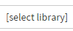 , tap Way Public Library from the drop-down menu, and then tap .
- On the next page you are taken to, tap the blank space under Library Card Number and type in your card number, and do the same for the Pin field (Note: If these fields are already filled in, make sure the numbers correspond with your library card and proceed to step 4, because this means you have signed in from this device before and have it setup to remember your information). Your library card number is the full list of numbers on the back of your library card, without the spaces. Your pin number is the last four digits of the phone number you provided when you applied for your library card. If your pin does not work, call the library to have a staff member look it up for you or change it. See if there is a checkmark in the box next to “Remember my login information on this device.” If there is not a checkmark, you may want to tap the checkbox to add a checkmark so that the next time you sign in on this device, the library card number and pin fields will already be filled in for you.
- Tap 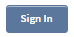 to finish the process and be taken to the catalog homepage.

Finding an Item in the Catalog
Before you starting browsing, always make sure you are signed in (Section C).
- To look for an available title you can:
  - Check out Featured Collections: From the Ohio Digital Library homepage, scroll down to see the featured collections that OverDrive changes frequently depending on the latest holidays, trends, popularity, etc.
  - Browse: Tap  at the top of the page (make sure it is the menu button next to the ”Account” button and not the menu button in the very top-left corner) to browse categories (on some devices the menu is already open, so tapping Menu may actually close the Menu; tapping Menu again will re-open it)
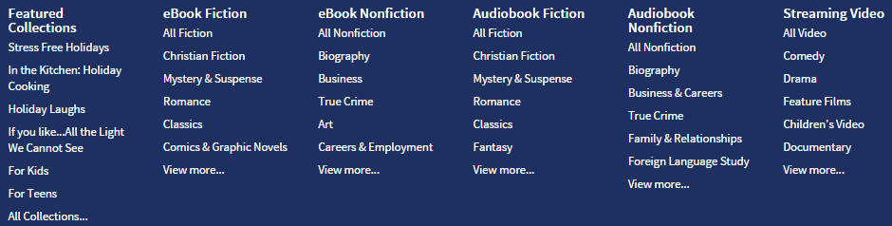
    - Note that if you select “View more…” at the bottom of any column, it will take you to a page with all of the books in that general section listed, and at the page it takes you to, you may tap the drop-down menu 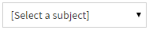at the top of the page to get the full list of catagories. Tap one of these categories to be taken to the page with only those items.
  - Run a search: Tap the white search box 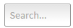in the top right-hand corner (on smaller devices you must first tap ) and type in a title, author, or keyword/subject

- All items have an icon in the top right-hand corner of its cover.
  - Item Type:  This icon means the item is an ebook
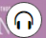 This icon means the item is an eAudiobook you listen to
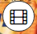 This icon means the item is a movie you watch
  - Availability: If the icon is black  it means the item is available. If the icon is grey  it means the item is checked out. If you are interesting in placing a hold on the item read Section I below.
- While you are looking at item results while browsing or searching, use the and buttons at the top and/or bottom of pages to flip forwards and backwards through pages of results.
- Sorting results: You may want to sort items you are browsing or searching for by most popular, publication date, date added to the library, or alphabetical by title or author. To sort items, tap the drop-down menu 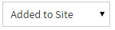 at the top of your results page and tap your selection.
- Filtering results: You may want to narrow down your browsing/search results by removing items that are checked out, selecting a certain subject, or other options. You may do so by looking at the options on the left-hand side of the screen (for iPads), or tapping Filter search by… at the top of the screen (for iPhones).
    - Note: Tap Available Now from the filter options to remove items that are checked out
- Find out more about an item: To read more about an item, tap its cover once and then tap to be taken to a page about the item. Then tap 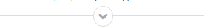 to read the full description. You may read a sample from the book by tapping  under the book’s cover.

Checking Out an Item
- When you find a title that looks interesting, tap the item cover and then tap 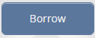.
- If you have not already signed in, you will be asked to do so at this time (Section C step 2 of this handout). Then you will be taken to your Checkouts page and can skip to Section F. If you had already signed in, you will instead see a box pop up for about 10 seconds. If you see the box tap the blue button Go to Checkouts. If the box disappears before you have a chance to tap it, scroll to the top of your screen and tap .

- Downloading an Item
After you checkout an item, it still must be downloaded to your device to read it. A title may only be downloaded on one device, so be sure to use the device you want the item on to complete the download process. For example if you are using your iPhone to browse for books but would rather read the item on your iPad, use your iPad to complete this section. If later you change your mind and want to download the item to a different device, you will need to delete it off of the first device you downloaded it to before attempting to download it to the other device (see Section H option 1).
- Go to your Checkouts Page if you are not already, by tapping at the top of any page from within the Ohio Digital Library.
- Find the cover of the item you want to download and tap 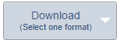(if it is a book),  (if it is an audiobook), 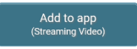 (if it is a movie), or 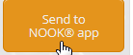 if it is a periodical. For ebooks a drop-down menu will appear and you may choose any format listed except for Kindle book. For ebooks the format you need is most likely EPUB book or Open EPUB book. Then tap Confirm and add to app.
    - Note: If you have an Amazon account and download the Kindle app on your device, you can select Kindle Book, follow the instructions on-screen to download the item from Amazon’s website, and then open the Kindle app to read the item. Otherwise, choose any of the other formats listed to download your item to the Overdrive app.
    - Note: If you're getting a magazine or newspaper, you'll see Send to NOOK app instead of Borrow. Ask a librarian for a “Downloading Periodicals” handout or go to help.overdrive.com for instructions. Once you tap Send to NOOK app you will be taken to the Barnes and Noble website to login to or create a Barnes and Noble account. After following the on-screen instructions you will need to download the free “Nook” app on your iOS device to read the magazine.

Reading/Listening To/ Watching an Item
- Within the OverDrive app, tap the menu icon in the top left-hand corner and tap Bookshelf.
- The first time you do this a tutorial will pop up; click OK, Got it! after reading the information.
- Tap the title you wish to read/listen to/watch.
  - For ebooks – Tap/swipe the left or right side of the screen to turn the page. Tap the middle of the screen to display read options and the menu button. One useful feature is tapping Aa at the bottom of the screen, and then the large A or the small a to change the font size. Tap the middle of the screen again to make the buttons go away.
  - For eAudiobooks – Once you tap the title it should start playing automatically. If it doesn’t, tap the play button at the bottom of the screen to play the item. Then hit the pause button at the bottom to pause the book. It will always save the spot you left off when you re-open the OverDrive app on the same device.
  - For videos – Once you tap the title it should start playing automatically. To pause, tap the center of the screen and then hit the pause button at the bottom of the screen.

Return an Item/Delete an Item
- Titles you've borrowed from the library will automatically be returned at the end of their lending periods. However, if you finish eBooks, audiobooks, or streaming videos before then, you can return them using the OverDrive app (to free up space on your library account). There are three options to do this, that each depends on the file type of the item.
Option 1 – For items you downloaded to your Bookshelf on your Overdrive app (such as EPUB eBook, PDF eBook, and OverDrive MP3 Audiobook)
  - From your app bookshelf (if you are not there, tape the menu button in the top left-hand corner and tap Bookshelf), tap and hold a title to display its return options.
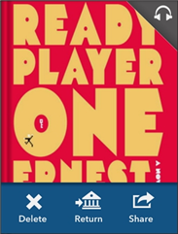
  - You can Return a title to the library, which also deletes it from your device.
You can Delete a title from your device, but you will still have it checked out to your library account. You will then have the ability to re-download it to the same device or a different device.

Option 2 (For items never downloaded, including books only read via Overdrive Read or listened to via Overdrive Listen on your internet browser)

- Go to the Overdrive catalog. You may be required to pull up your Overdrive app menu by tapping the Menu icon of the 2 horizontal lines in the top left-hand corner, and then tapping “Ohio Digital Library.”
- Go to your Account by click the icon of the little person at the top of the screen. 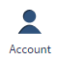
- Scroll down until you see the item you want to return, and then click 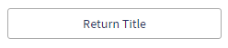as listed below the item. If you do not see this button, it means the item was already downloaded (in which case go to back to Option 1) or, if it is a Kindle book, it was already added to your Amazon account (in which case go to Option 3).

Option 3 (For Kindle books that have already been added to your Amazon account and/or downloaded to a Kindle device or added to the Kindle Reading App or Cloud Reader and are NOT in the OverDrive app).

- Go to your device’s browser (on a Kindle Fire go to your device’s home screen and scroll the menu at the top that starts with “Shop,” and then tap Web. Go to www.amazon.com and click “Log In’ in the top right-hand corner, unless you see “Hello, [your name here]!” in the top right-hand corner, in which case you may proceed to step 2.
- Put your cursor over “Hello, [your name here]! Your Account”  in the top right-hand corner, and you should see a menu drop down.
- From the drop-down menu, click “Manage Your Content and Devices” (listed about halfway down the list).
- Scroll down until you see the title of your item.
- Click the small square of three dots , located just to the left of the title of the item (in the “Actions” column).
- In the box that pops up, click “Return this book”.
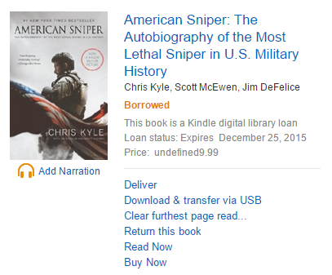
- In the box that pops up, click “Yes.”

Placing a Hold / Checking Out a Hold
- As you are browsing the catalog you may find items that are checked out. You may tap the item and then tap 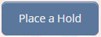, where you will be taken to a page that asks for your email address. Once the item becomes available you will receive an email letting you know the hold is available.
- When you placed the hold if you selected the option to automatically checkout the item when it becomes available, you can find the item under your Checkouts page once the hold becomes available, and it just needs to be downloaded. See Section F on how to do this.
- When you placed the hold if you did not select the option to automatically checkout the item when it becomes available, you will first need to go to your Holds page. Go to the Ohio Digital Library (Section B), go to your Account by clicking at the top, and then tap Holds. Then tap Borrow next to the available item.
- Go to your Checkouts page to download the item (see Section F).

Renewing Items
- You may only renew an item when it is within three days of its due date. Go to the OverDrive catalog (see Section B) and click Account at the top. If an item is eligible for renewal there will be a Renew button under the item.
- Once the first loan period expires, the item will be re-checked out to you. Visit your Checkouts page by repeating step 1 to re-download the item. If you do not see the item (meaning you did not set it up to automatically check out once the item is renewed), visit your Holds page by repeating step 1 above and then tapping Holds. Tap Borrow next to the item you want to check out, and you should be taken to your Checkouts page where you can download the item (see Section F).

Do you have additional questions?
Stop in the library or give us a call! We are happy to help.
For questions call the Technology Department at (419) 874-3135 option 4
You can also make a “Mondays with Kara” appointment, which is a 30-minute session with our Technology Specialist Kara Prielipp. Bring your device to your appointment or use one of our computers and ask technology-related questions, including information on accessing OverDrive materials.
To make an appointment call the Information Desk at: (419) 874-3135 ext. 119

Way Public Library
101 E. Indiana Ave.
Perrysburg, OH 43551

