How to get Audiobooks on an iPod with OverDrive

1. Use a computer to go to app.overdrive.com
2. Scroll to the bottom of the page, and click **Download for Windows Desktop** to download “OverDrive for Windows Desktop” if you have a Windows computer, or click **Available for Mac** to download OverDrive for Mac.
3. Go to ohdbks.lib.overdrive.com and **Sign In** in the top right-hand corner.
4. Browse by subject or use the search bar to find an item to checkout.
5. Put your cursor on an item you wish to read, click **Borrow**, and click **Go to Checkouts** in the pop-up window. At your Checkouts page, click **Download** next to the book you want.
6. Open the file you downloaded. It should open up with OverDrive for Windows or OverDrive for Mac. After the item downloads plugin your iPod, click the item, and click **Transfer** to move it to the iPod.
7. After the item is done transferring, you may remove the iPod from the computer.
8. When you listen to the item on your iPod, you will find it listed under “Music.” If you are interested in getting the item categorized under “Audiobooks” instead, follow the instructions on the next page.

How to categorize MP3 audiobooks in iTunes

MP3 audiobooks are stored under "Music" in iTunes by default. If you prefer, you can categorize an MP3 audiobook so that it shows up under "Audiobooks" instead using the steps below.

**What you need**

* A computer (Windows or Mac)
* An MP3 audiobook transferred to your Apple device (iPhone, iPad, or iPod)
* The USB cable that came with your iPhone, iPad, or iPod
* [The latest version of iTunes](http://overdrive.com/partners/redirects.aspx?product=itunes)

**How to change the "Media Kind" for audiobooks in iTunes**

1. Connect your Apple device to your computer using your USB cable.
2. Open iTunes (if it doesn't open automatically).
3. Select the **Device** button near the top-left corner of iTunes.  
   Screenshot of the Device button in iTunes
4. Under "On My Device," click **Music**.
5. Right-click (or control-click on a Mac) an audiobook file, then click **Get Info**.  
   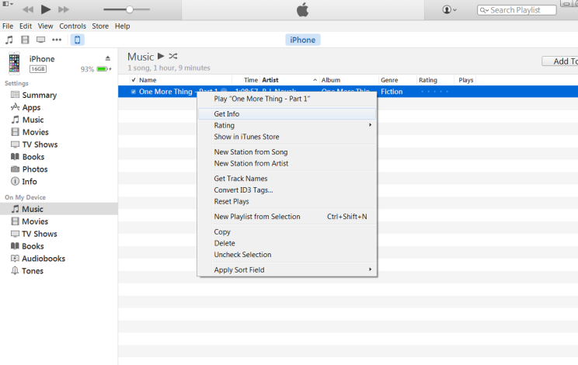
6. In the pop-up window, click the **Options** tab.
7. In the "media kind" drop-down menu, select **Audiobook**.  
   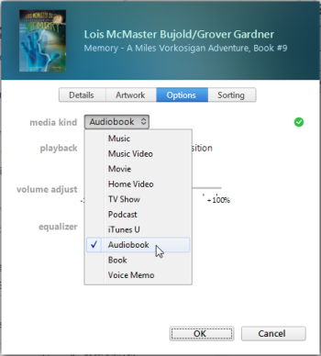
8. Click **OK**.

You'll now find the audiobook file(s) under "Audiobook" on your device.