PRESS RELEASE

WILLIAM P. FAUST PUBLIC LIBRARY OF WESTLAND
6123 Central City Parkway, Westland, Michigan 48185
April 19, 2018, for immediate Release

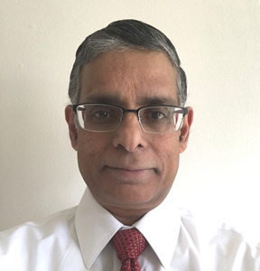

Ishwar Laxminarayan named as Library Director

WESTLAND, MI- The William P. Faust Public Library of Westland Board of Trustees is pleased to announce it has selected Ishwar Laxminarayan as its next Library Director effective June 11, 2018. Ishwar brings over 25 years of library experience, including 10 years as the Director of the Jackson District Library in Jackson, Michigan. The decision follows a nationwide search and finalist interviews on April 11, 2018.

At the Jackson District Library, Ishwar led a countywide library system that served a population of over 160,000 through a network of 13 branches. He has wide experience with library expansions, strategic planning, millage campaigns, and implementing collection, technology and programming enhancements.

Library Board President James Higgins said “We are excited to name Ishwar Laxminarayan to the position of Director of the William P. Faust Public Library of Westland. We believe with his unique experience in library leadership he has the vision to move the library forward. We are pleased that the staff and Library Board shared the same sentiment regarding Ishwar’s selection as the Library Director.”

Mr. Laxminarayan is eagerly looking forward to leading the William P. Faust Public Library of Westland and said “ I am delighted at this opportunity to work with a great staff and dedicated trustees to provide the highest quality library services to the Westland Community.”

Ishwar possesses a Master of Librarianship from Emory University in Atlanta, Georgia and has attended the Senior Executives in State and Local Government program through a Public Library Association Fellowship award. He is a member of the American Library Association and Public Library Association.

A community gathering will be held at the Library to introduce Mr. Laxminarayan at a future date.

p/wl/library/Director 2018/Director Press Release

