**NEW LIBRARY PLANS – COOL FEATURES (with informal coffee discussion)**

**Original question**

**From:** Melissa Huisman   
**Sent:** Thursday, July 20, 2023 11:02 AM  
**To:** Michlib-L@Mlc. Lib. Mi. Us (michlib-l@mlc.lib.mi.us) <michlib-l@mlc.lib.mi.us>  
**Subject:** New Library plans

Hi!  We are working on preliminary drawings for a combined library/community center. Has anyone built or remodeled recently and can enthusiastically recommend some feature that you really love?

Podcast studio? – sensory feature? – computer station for adult/babycrib? – I’m open to anything!

Thank you!  Melissa

**\*\*\*\*\*\*\*\*\*\*\***

Hi Melissa,

How exciting! We opened a new branch in 2021. You can take a virtual tour here:  <https://my.matterport.com/show/?m=PafW1PGx9fF>

Some of the fun features of this building include outdoor musical instruments between the parking lot and east entrance, floor pocket displays, special early literacy area, a table that is half inside and half outside.

Best wishes on finding the right special feature for your building!

Help with video tour:

You can click and drag and turn without clicking on each circle. For a video tour:

1. Macomb Township Cable – Tour (13 minutes) - <https://www.youtube.com/watch?v=GPYpJoZwN74>
2. Macomb Township Cable – Overview of new DIA artwork that was unveiled in January (speeches are at the start, the artist talks about it later on) - <https://www.youtube.com/watch?v=A2_U60-dgiA>

Kids area décor: Great! It’s the Burgeon Group:  <https://www.burgeongroup.com/>

**\*\*\*\*\*\*\*\*\*\*\***

Hi Mary,

If you haven’t already, you should conduct a community needs assessment.  Also, your architect should be up on the latest library services and be able to guide you.  But, you should always refer to your community needs assessment.

Good luck!!

**\*\*\*\*\*\*\*\*\*\*\***

Hi Melissa,

We built a new library and opened a year ago in our new location. I love everything about our library but some highlights are:

* a floor to ceiling stone fireplace with comfortable seating all around

* a "magic book" in our children's area

* a majestic tree with singing birds, a buzzing hive and hidden creatures in our children's area

* soaring wood ceilings that make the space look almost church-like and visually stunning

* electrochromic glass in 100% of the building's windows. This glass, called SageGlass, automatically dims when the sun hits it and lightens when the sun goes down, eliminating the need for window tinting, shades or other window treatments.

* outdoor space with a stamped concrete patio, permanent outdoor furniture, and green space behind the library. Summer storytimes on the lawn with 50+ kids this summer has been awesome!

* Five enclosed and sound-resistant private study rooms that seat up to 8. They are busy from the minute we open until we close every day.

*Our "Legacy Room", a community room with enough space to seat 200, outfitted with a 9 foot video wall, kitchenette, modular tables that are wired for power and (smartly) floor boxes for power about every 6 feet.

If you look us up on google, I have added a ton of pictures to our google entry. Just click on "View pictures" and look for the dates for ones within the last year.

You are more than welcome to roadtrip and visit anytime! I'm happy to give you a tour and take you to lunch. :)  
  
**\*\*\*\*\*\*\*\*\*\*\***

Hi Melissa:

I recommend getting in touch with the folks at Cheboygan Area Public Library. I was very impressed with their community spaces in the basement which can be accessed separately from the actual library.

**\*\*\*\*\*\*\*\*\*\*\***

Hi,

We have these in the youth room in between the picture book shelving and the patrons love to sit in them and read

<https://www.demco.com/demco-reg-colorscape-reg-playpod-house>

Good Luck with your reno!

**\*\*\*\*\*\*\*\*\*\*\***

What a WONDERFUL idea-- something we strive to be, but need more space to really make come alive!

We're really hampered by lack of space-- have often had community member who want to "gather" here for quiet group activities, chats, etc. So.. you might consider allocating space for "gathering spaces" for puzzle makers, knitters, tabletop game-players, etc. Tables that can be solo or pushed together for multiple people, access to views, fireplace, etc for that comfy feel.

Have fun and good luck!

**\*\*\*\*\*\*\*\*\*\*\***

Having worked at several libraries, I can suggest that having a large indoor book drop with an outdoor slot will probably be helpful.

I have also heard good things about having a place where people can tell their life stories, family stories, etc, and get them preserved, and possibly added to a local history collection of some sort. As far as that goes, possibly have a local history room?  But that depends on the needs and desires of the community, of course.

The other minor practicality that comes to mind is window shades, again depending on the direction and placement of windows, etc.

Hope it turns out well. The planning must be a neat thing to be involved in.

**\*\*\*\*\*\*\*\*\*\*\***

**From:** Pamela Williams <[erlib.director@gmail.com](mailto:erlib.director@gmail.com)>   
**Sent:** Thursday, July 20, 2023 3:56 PM  
**To:** Melissa Huisman <[mhuisman@hudsonville.org](mailto:mhuisman@hudsonville.org)>  
**Subject:** Library and community center

Hi Melissa. I saw your post on michlib. Our library is also considering the same for our community. We just signed a purchase agreement for an option to buy a manufacturing building that would suit the needs of the library and a community center.  We have 6 months to determine if we want to buy the building.  I would love to be a part of your brainstorming as you go through the process. Right now our ideas are just starting to bloom:

ping pong tables for winter months

day care

community  meeting room

test kitchen

tutoring space

lego room

maker space

Not sure how we are going to staff this room, like I said we are in the beginning stages. Any information or successful models of a library/community center you might know would be appreciated.

Good luck with your project! It is exciting to have a blank slate!

**\*\*\*\*\*\*\*\*\*\*\***

Coffee!

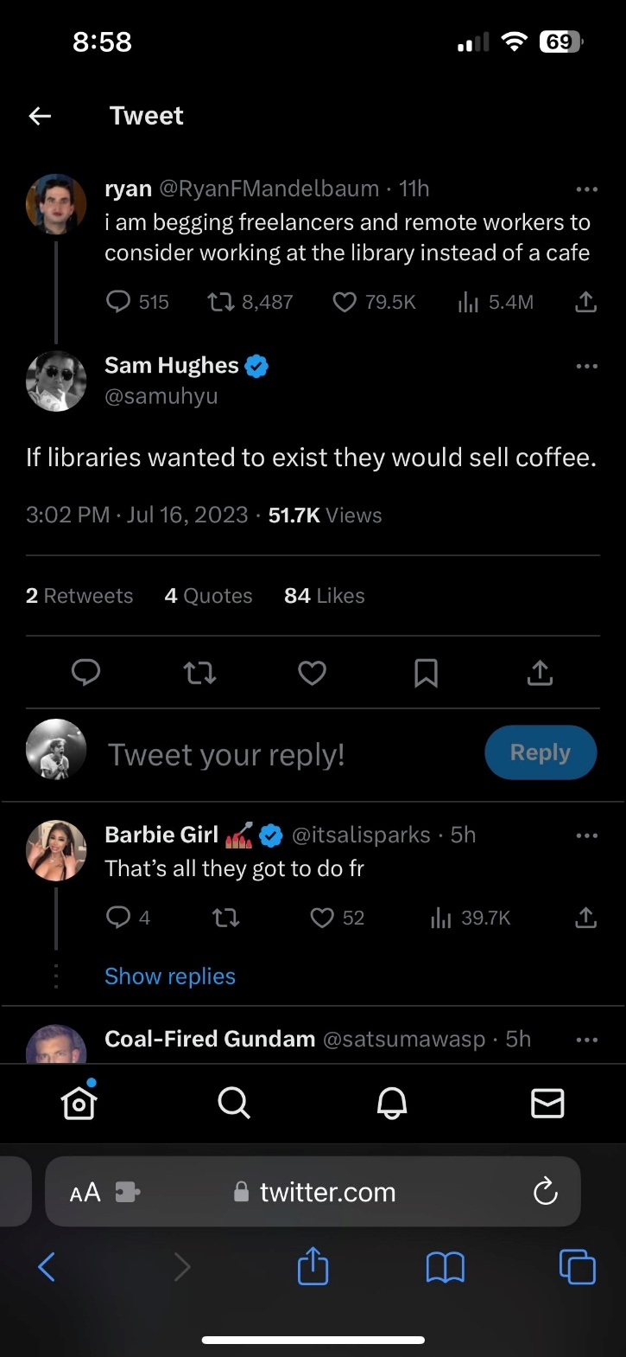

**\*\*\*\*\*\*\*\*\*\*\***

Hi Melissa,

We offer vending machines in café spaces which is where we encourage people to snack and bring their own food. I have heard a few horror stories about café spaces in libraries over the years. There can be health department issues, the hours a coffee shop needs to be open to make a profit is different from the library. If your project is paid for by bonds there are formulas per the percentage of space allowance before you get into tax issues, etc. I believe the Ypsilanti District Library has a coffee shop, it may even be a big name. In Farmington Hills the elimination or change in a café space snowballed into a huge political nightmare. I think Commerce Township offered a microwave or a few more amenities beyond vending.

Again, I think café spaces are great, but would be careful about the extent of the services.

**\*\*\*\*\*\*\*\*\*\*\***

Yes! We still have our attached bakery and it's a huge benefit for them and us. Many people stop in because they happened to be at the bakery and vice versa.

We also offer free coffee at the circ desk once a month after a Chamber of Commerce meeting. That seems to be popular also (or maybe it's staff drinking it) (or me. maybe it's just me drinking it).

We also serve lunches all summer so we have a very loose policy about food and drink in the library, always a surprise to new patrons. We rarely have messes or spills.

**\*\*\*\*\*\*\*\*\*\*\***

Hi, Melissa-

We have a coffee bar set up. We have a Keurig and offer coffee, tea, and hot cocoa. It's $1/cup, and we provide all the fixings (creamer, sweetener, stirrers, etc.). I have not had any issues that would make me discontinue the service.

**\*\*\*\*\*\*\*\*\*\*\***

NO! I can explain my vehement response. I worked at two prior libraries that had coffee shops that just couldn't keep ANY vendor in that space. We cycled through vendor after vendor that said they'd make a go of it, but there just wasnt enough foot traffic to keep it up and running. Both libraries were HUGE Class VI libraries in suburban Detroit.  Both libraries ended up re-purposing that space into some other kind of useable space like a vending area and a Friends Bookstore. I would like to find a coffee vending machine that could offer a decent cup but so far have come up empty-handed as those are very pricey and are vending companies usually only put in place those in areas that have high traffic like hospitals and hotels. We do have a beverage vending machine (pop, energy drinks, water, cold coffee drinks, etc) and we're looking at add a snack machine.