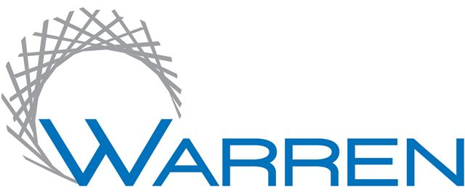

Warren Public Library
One City Square, Suite 100
Warren, MI 48093-2396
(586) 574-4564
www.warrenlibrary.net
Oksana Urban, Director

FOR IMMEDIATE RELEASE: FOR MORE INFORMATION CONTACT:

Andrea Mucha, 586-353-0580 amucha@cityofwarren.org
May 23, 2019

Warren Public Library Hosts
“Astronomy 101”
on Wednesday, June 26, at 6:00 p.m.”

Jonathan Kade, a member of the Warren Astronomical Society, will present a program discussing the universe around us.

This program will be held in the Busch Branch Library at 23333 Ryan Road, 2 blocks north of 9 Mile Road.

Registration is required; space is limited. For more information or to register, call 586-353-0580.

# # #

