

**LIBRARY ASSISTANT I (CIRCULATION)**

Posting Date: February 24, 2025 Closing Date: March 10, 2025

Position Availability: Immediately

|  |  |
| --- | --- |
| Reports to: | Head of Circulation Services |
| Schedule: | Part-time, 25 hours per week. Flexible schedule to include days, nights, and weekends. |
| Union Position: | Yes, Westland Library Union SEIU Local 517M (Non-Supervisory) |
| Starting Wage: | $14.32 per hour |
| Benefits: | Prorated vacation leave, personal leave, and paid holidays for employees working 20 or more hours per week. Employer-provided contribution to retirement (401a) after meeting service requirements. |

Posting

**SUMMARY:**

Under the direction of the Head of Circulation Services, the Library Assistant I directly serves patrons by checking in and checking out materials, registering patrons, collecting money for fines and fees, and answering simple patron queries. Performs a wide variety of routine and occasionally complex clerical and computer work. Works with staff throughout the library on projects that enhance the library’s image in the community.

**EDUCATION AND EXPERIENCE:**

* High School Graduation or GED. Some college coursework preferred.
* 1-2 years of customer service or retail experience, preferably in a public library.

Please submit your application online via our website at www.westlandlibrary.org/jobs.

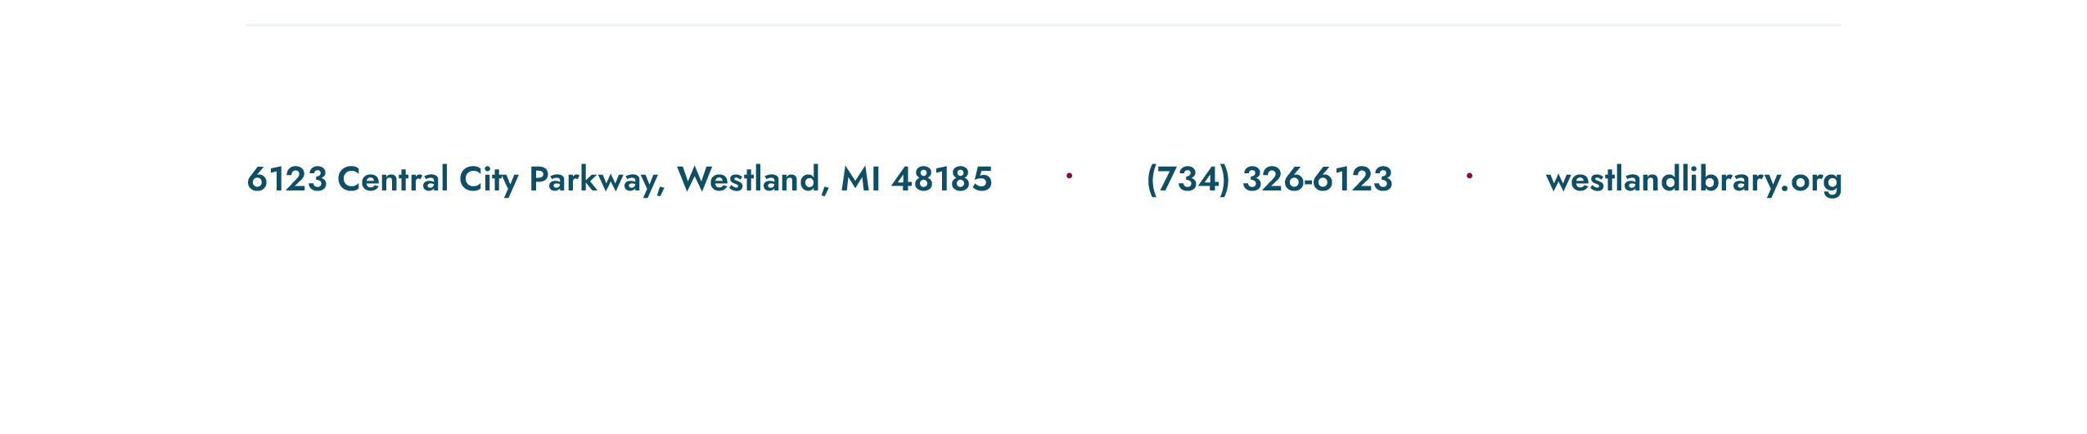*The library is an EEO Employer.*