Job Description
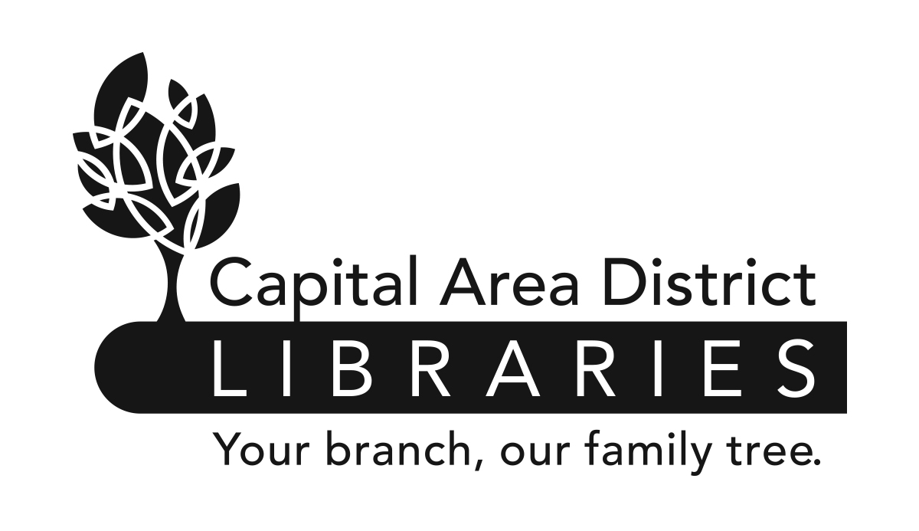
Position: Collection Development Specialist (NF)

Range: P3 (Exempt) (Union)

Reports to: Associate Director of Collection Services

Supervises: None

Reviewed: 10/15

Revised: 04/19

Job Summary

Under the supervision of the Associate Director of Collection Services, coordinates adult materials selection and ordering for non-fiction and audiovisual materials, assists with collection maintenance and assists in programming ideas for adult patrons. Also instrumental in developing service goals and supplemental services.

Duties and Responsibilities

- Responsible for all central selection of adult non-fiction, music CDs and DVD/Blu-ray materials.

- Identifies collection and subject trends and incorporates them into collection maintenance and shelf-space allocation.

- Uses Collection HQ and other tools to analyze collections for use trends and to assist branch staff in weeding, transferring and updating collections.

- Communicates with vendors regarding library materials to keep current with new products and features.

- Monitors annual materials budget and ensures appropriate purchasing timeline. Utilizes cost-effective methods for selection.

- Coordinates and provides programming ideas for library staff.

- Writes responses to Citizen’s Reconsideration requests for adult non-fiction and audiovisual materials.

- Contributes to Readers Advisory Committee.

- Contributes to staff Readers Advisory newsletter, Readers Advisory content on the CADL website and social media, and other Readers Advisory efforts such as podcasts.

- Provides selection support for outreach and public service special projects.

- Works with Marketing to promote adult events and areas of the collection.

- Serves as a CADL representative to vendors of library collection materials.

- Assists staff with issues related to online ordering systems.

- Orders fiction and audiobook titles in the absence of the Adult Fiction Specialist.

- Works with the Associate Director of Collection Services to evaluate CADL’s databases, and researches and recommends new databases and digital services.

- Other duties as assigned.

The above statements are intended to describe the general nature and level of work being performed by people assigned this classification. They are not to be construed as an exhaustive list of all job duties performed by personnel so classified.

Job Requirements

- Possession of a Master’s Degree in Library Science or its equivalent from an ALA accredited institution.

- Possession of a Librarian’s Professional Certificate from the Library of Michigan.

- Minimum of two years experience in public libraries working with the public and/or materials selection.

- Successful completion of a one-year probationary period.

- Be physically able to perform the essential functions of the job with or without reasonable accommodation.

- Knowledge of library organization, materials, services, and policies and procedures.

- Knowledge of the principles and methods of evaluating library materials and equipment.

- Thorough knowledge of books and current interests of the public.

- Ability to initiate ideas for the improvement of functions and services.

- Ability to use computers and to utilize computer databases.

- Effective written and oral communication skills.

- Ability to provide advisory service to community libraries.

- Ability to supervise, direct, and organize the work activities of others.

- Ability to establish and maintain an effective working relationship with co-workers, vendors, staff of community libraries, and the public.

- Ability to conduct oneself with tact and courtesy.

