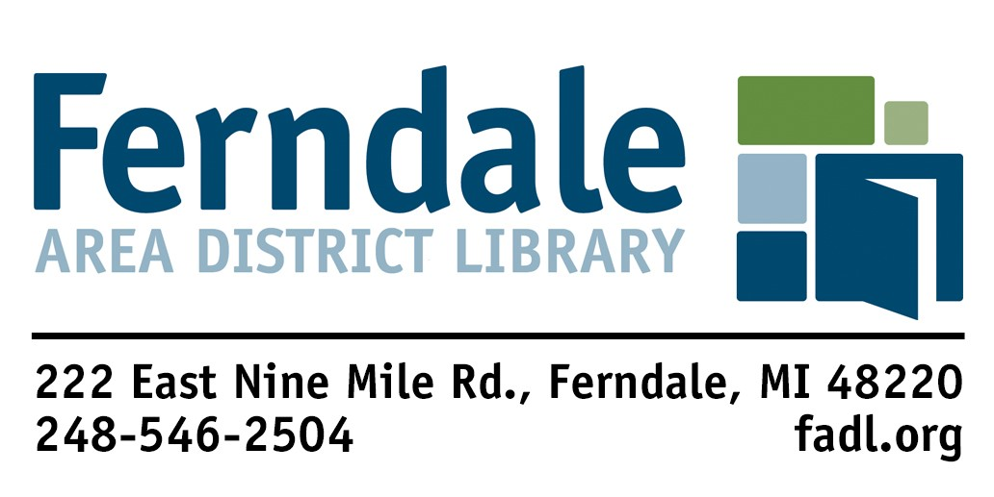

**Request For Reconsideration**

**of Library Material**

**Our Mission**

The Ferndale Area District Library strengthens the community by providing access to materials and services that inform, enrich, entertain, and empower.

**Our Vision**

The Ferndale Area District Library is a leader in building and sustaining Ferndale as a creative city that attracts and nurtures talent, mobilizes ideas, stimulates innovation, and encourages diversity. The library is a center of cultural vitality and participation that enhances the quality of life for all Ferndale residents.

The Library Board of Directors has delegated the responsibility for selection and evaluation of collection materials to the Library Director and has established reconsideration procedures to address concerns about those resources.

Completion of this form is the first step in those procedures. If you wish to request reconsideration of library materials, please return a completed form c/o the Library Director, Ferndale Area District Library, 222 E. 9 Mile Rd, Ferndale, MI, 48820. All decisions of the Board are final.

Only forms that are 100% completed will be accepted. The Library Director has up to sixty (60) days to complete the reconsideration process for each form. The material being reconsidered must be read in full by the applicant.

Name: _____________________________________ Date: __________________________

Address: _____________________________________________________________________

City: _______________________ State: _________ Zip code: _______________________

Phone: __________________________ Email: _____________________________________

Are you a FADL cardholder or do you live, work, own property, or attend school in our service area?

Yes ______ No ______

Who do represent? Self _______ Organization _______

If organization, please provide the name: ___________________________________________

Title:________________________________________________________________________

Author:________________________________ Type of Material: _______________________

(Artist, Performer, etc.) (Book, DVD, Program, etc.)

Did you read, view, or listen to the entire work? Yes _____ No _____

Have you read any professional reviews of this work? Yes _____ No _____

If yes, please list publication(s) here: ________________________________________________

______________________________________________________________________________

______________________________________________________________________________

What do you believe is the major theme or intent of this work?____________________________

______________________________________________________________________________

______________________________________________________________________________

What is your objection to this work? Please be specific. _________________________________

______________________________________________________________________________

______________________________________________________________________________

What do you feel might be the result of reading, viewing, or listening to this work?

_______________________________________________________________________________

_______________________________________________________________________________

What action do you wish to be taken? ________________________________________________

_______________________________________________________________________________

Please explain how such an action would improve the Library’s service to the community:

_______________________________________________________________________________

_______________________________________________________________________________

In its place, what work of equal literary quality would you recommend the Library purchase that would cover the same subject or content?

______________________________________________________________________________

______________________________________________________________________________

______________________________________________________________________________

___________________________________ _____________________________________

Signature Date

Completed forms should be delivered to:

Ferndale Area District Library

Attn: Library Director

222 East Nine Mile Road

Ferndale, MI 48220

Updated 7/21/2022