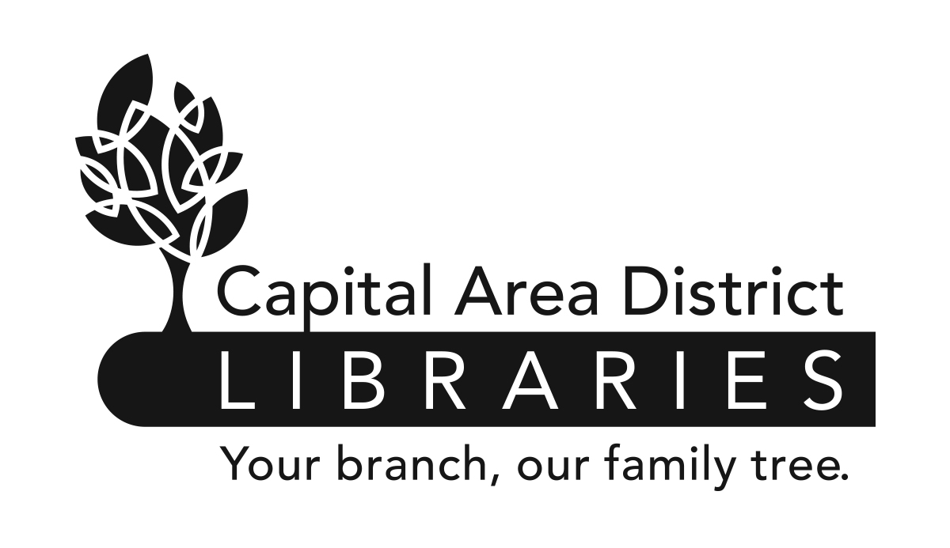
Job Description

Position: Youth Specialist

Range: P3 (Exempt) (Union)

Reports to: Associate Director of Collection Services

Supervises: None

Reviewed: 06/17
www.cadl.org

Revised: 06/17

Job Summary

Under the supervision of the Associate Director of Collection Services, plans, directs and supports the overall library program of service to children and young adults. Also instrumental in developing service goals and supplemental services.

Duties and Responsibilities
- Responsible for centralized selection of youth materials in all formats (print, DVD, Overdrive ebooks and eAudiobooks).

- Identifies collection trends and incorporates them into collection maintenance and shelf-space allocation.

- Uses CollectionHQ and other tools to select materials and assists branch staff in weeding, transferring and updating collections.

- Communicates with vendors regarding library materials to keep current with new products and features.

- Monitors annual materials budget and ensures appropriate purchasing timeline. Utilizes cost-effective methods for selection.

- Chairs the Youth Services Committee and participates in the Reader’s Advisory Committee.

- Coordinates the Summer Reading Program, including attending planning meetings, setting up online Summer Reading in Beanstack, selecting prizes, and collection of evaluation and statistics. Works with Marketing to produce print reading logs and publicity.

- Trains local staff in all aspects of youth services, programs and materials.

- Writes responses to Citizen’s Reconsideration requests of youth materials.

- Works with Marketing to promote youth events; works with Marketing and IT to continue development and update the Kids & Teens section of the website.

- May participate in community outreach and act as liaison to youth related community organizations.

- Other duties as assigned.

The statements are intended to describe the general nature and level of work being performed by people assigned this classification. They are not to be construed as an exhaustive list of all job duties performed by personnel so classified.

Job Requirements

- Possession of a Master’s Degree in Library Science or its equivalent from an ALA accredited institution.

- Possession of a Librarian’s Professional Certificate from the Library of Michigan.

- Minimum of two years experience in public libraries working with the public and/or materials selection.

- Successful completion of a one year probationary period.

- Be physically able to perform the essential functions of the job with or without reasonable accommodation.

- Knowledge of library organization, materials, services, and policies and procedures.

- Knowledge of the principles and methods of evaluating library materials and equipment.

- Thorough knowledge of books and current interests of the public.

- Ability to initiate ideas for the improvement of functions and services.

- Ability to use computers and to utilize computer databases.

- Effective written and oral communication skills.

- Ability to provide advisory service to community libraries.

- Ability to supervise, direct, and organize the work activities of others.

- Ability to establish and maintain an effective working relationship with co-workers, vendors, staff of community libraries, and the public.

- Ability to conduct oneself with tact and courtesy.

Youth Services Specialist Job Description
Page 2 of 2

