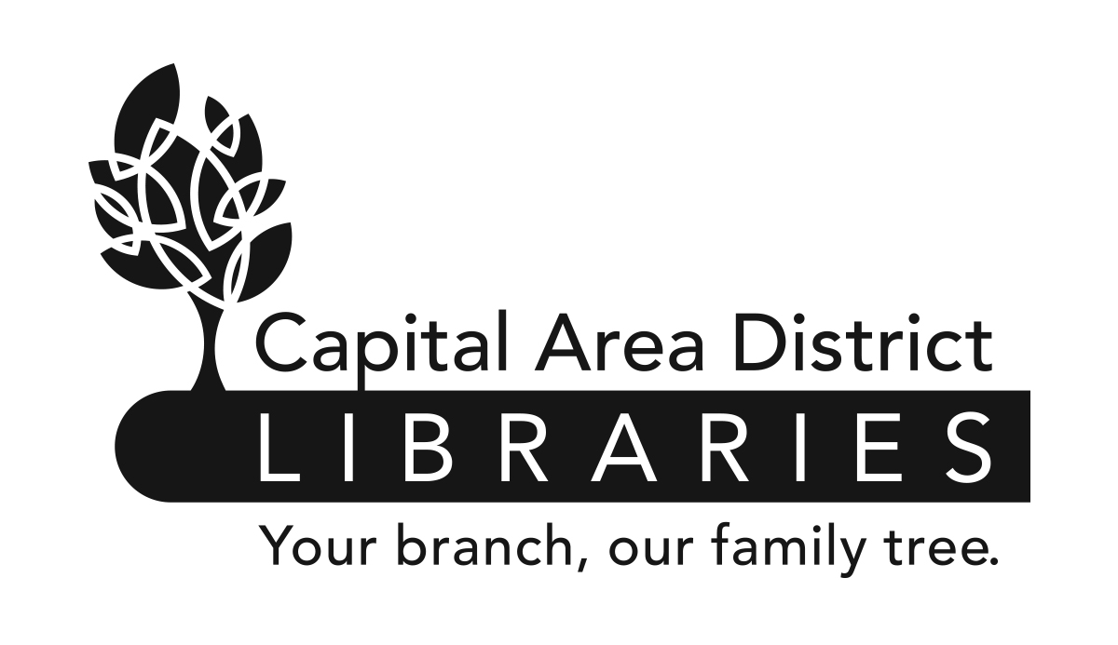

JOB ANNOUNCEMENT

DATE: June 15, 2017

POSITION: Youth Specialist

HOURS & Capital Area District Libraries Headquarters, 401 S. Capitol
LOCATION OF Avenue, Lansing, MI 48933
EMPLOYMENT: Full-time. 40 Hours/week. May include evenings and weekends.

Capital Area District Libraries (CADL) provides library services to our local communities seven days per week. All positions will require some evening and weekend hours, including Sundays. While this position is currently assigned at the above location, CADL reserves the right to require all employees to be available for assignments at any CADL location.

EDUCATION & EXPERIENCE:
Possession of a Masters' Degree in Library Science or its equivalent from an ALA accredited institution.
Possession of a Michigan Librarian's Professional Certificate.
Minimum of two years experience in public libraries working with the public/and or materials selection.

NATURE OF WORK: Under the supervision of the Associate Director of Collection Services, plans, directs and supports the overall library program of service to children and young adults.
Also instrumental in developing service goals and supplemental services.

SALARY: $56,775 (plus benefits)

DEADLINE TO Must be received by 5:00 p.m. Monday, June26, 2017.
APPLY:

FOR DETAILS Contact the Capital Area District Libraries, 401 S.
AND/OR Capitol Avenue, Lansing, Michigan, Monday-Friday,
APPLICATION: 9am-5pm, (517) 367-6300 or visit www.cadl.org/jobs

Please send a completed Capital Area District Libraries Application* to: Capital Area
District Libraries, Attn: Human Resources, PO Box 40719, Lansing, MI 48901-7919.

*All applications for employment must be made on the Capital Area District Libraries application form and completed in full. Resumes will not be accepted or evaluated in lieu of application. All applicants must meet the minimum and special eligibility requirements, as listed on this job announcement, for the vacancy and file a timely application in order to be considered. Separate application forms must be submitted for each position for which an applicant wishes to apply.

CAPITAL AREA DISTRICT LIBRARIES SYSTEM
IS AN EQUAL OPPORTUNITY EMPLOYER.

