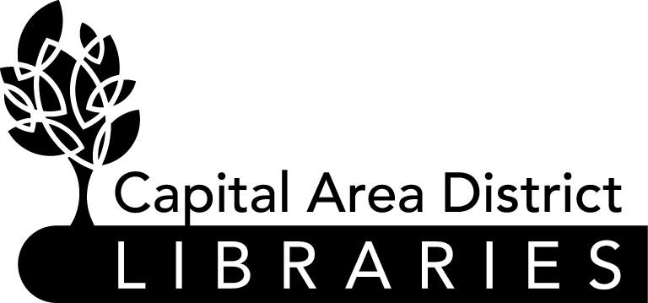

JOB ANNOUNCEMENT

DATE: October 10, 2022

POSITION: System Administrator

HOURS &LOCATION Downtown Branch, 401 S. Capital Avenue, Lansing, MI 48933.
40 hours per week.
OF POSITION:

EDUCATION /Experience: Associate’s or bachelor’s degree in a related field.
        - Demonstrated competency in the following:
        - Microsoft Windows network and server administration,
        - Microsoft 365 administration,
        - layer 1-4 networking fundamentals,
        - a network and data security framework
        - PowerShell
        - Experience installing and managing networks for a multi-location organization.
        - Experience installing and managing servers in an organization with 100+ desktops.

NATURE OF WORK: Under the supervision of the Director of Technology, this employee designs and administers all CADL networks and on-premises servers, administers CADL’s Microsoft 365 tenant, and ensures network and data security.

SALARY: $63,288-$79,138

DEADLINE TO APPLY: Must be received by October 24, 2022, by 5:00 p.m.

FOR DETAILS AND/OR Contact the Capital Area District Library, 401 S.
APPLICATION: Capitol Avenue, Lansing, Michigan, Monday-Friday,
9am-5pm, (517) 367-6300 or visit www.cadl.org/jobs

Please send cover letter, current resume, and a completed Capital Area District Libraries Application* to: Capital Area District Libraries, Attn: Human Resources, 401 S. Capitol Ave., Lansing, MI 48933.

**All applications for employment must be made on the Capital Area District Library application form and completed in full. Resumes will not be accepted or evaluated in lieu of application. All applicants must meet the minimum and special eligibility requirements, as listed on this job announcement, for the vacancy and file a timely application in order to be considered. Separate application forms must be submitted for each position for which an applicant wishes to apply.

THE CAPITAL AREA DISTRICT LIBRARIES SYSTEM IS AN EQUAL OPPORTUNITY EMPLOYER.

