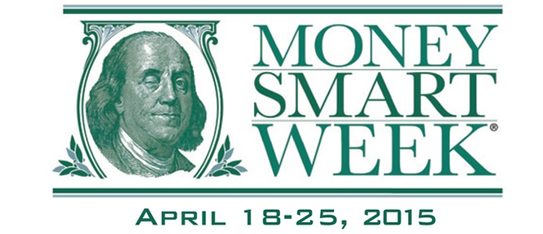

“Money Smart Week @ your library” is a national initiative between the American Library Association and the Federal Reserve Bank
to provide financial literacy programming.
The Warren Public Library is proud to host the following three events to help us keep our ledgers in the black and our pockets filled with green!
1: Find Work You Love: Five Ways to Transition from an Ordinary Job to an Extraordinary Career! with Career Coach Julie Carr - Frustrated with your job? Then this is the workshop for you! Turn that job into a rewarding career with these helpful strategies and tips.

2: Family Financial Planning - This is a seminar on general financial planning for you and your family. A representative from Hantz Group will cover various topics relating to: budgeting, debt management, mortgages, college financing, and more. There will be a session for the kids too!

3: Marriage & Money with Heidi McCarroll of Primerica – This session is aimed at giving married couples a no-nonsense approach to setting and achieving financial goals. You will learn strategies to set short and long term goals and how to build a budget.

Miller Branch Library

Family Financial Planning
for adults and kids

Monday, April 20 @ 6:30-7:30 p.m.

Civic Center Library

Find Work You Love: Five Ways to Transition from an Ordinary Job to an Extraordinary Career!

Monday, April 20 @ 6:00-8:00 p.m.

Civic Center Library

Marriage & Money with Heidi McCarroll of Primerica

Wednesday, April 22 @ 6:00-8:00 p.m.
*Please note change of date*



