**Harper Woods Library**

**Book Club 2024 – Wednesdays, 1:30 p.m.**

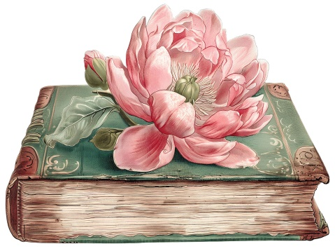

January 24 Fiona Davis *Any historical fiction book by this author*

February 28 Alka Joshi *The Henna Artist*

March 27 Louise Erdrich *The Sentence*

April 24 Angeline Boulley *Firekeeper’s Daughter*

May 22 Bill O’Reilly *Any book in the “Killing” series*

June 26 Geraldine Brooks *Horse*

July 24 Fredrik Backman *Anxious People*

August 28 Fannie Flagg *The Wonder Boy of Whistle Stop*

September 25 Toni Morrison *Recitatif*

October 23 Oscar Wilde *The Picture of Dorian Gray*

November 20 Pip Williams *The Dictionary of Lost Words*

December 18 Les Standiford *The Man Who Invented Christmas*