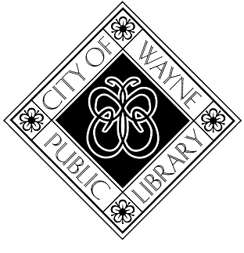Wayne Public Library

Employment Opportunity

**Position:** Circulation Clerk

**Hours:** approximately 10-20 hours per week,

primarily afternoons, evenings, and occasional Saturdays

**Location:** Wayne Public Library, 3737 S. Wayne Rd., Wayne, MI 48184

**Responsibilities:**

* Check materials in and out to patrons
* Handle fines, payments, and receipts
* Process returned materials, holds, and other materials from the TLN delivery
* Follow procedures for dealing with missing and damaged books
* Search and maintain patron records, ensuring accuracy and privacy
* Issue library cards
* Welcome patrons and provide directions
* Answer the main phone and direct calls as needed
* Sort library materials and help shelve as needed
* Open and close library building
* Assist with special projects
* Other duties as assigned

**Requirements:**

* High school diploma
* Experience working in a customer service role
* Experience working with computers
* Strong organizational skills and attention to detail
* Strong interpersonal, communication, and technology skills
* Enthusiasm and commitment to excellent public service
* Ability to lift and/or carry objects weighing up to 20 pounds

**Wage:** $13 - $17/hr

**To apply:** Applications are available at <https://www.cityofwayne.com/DocumentCenter/View/222/Application-for-Employment-PDF>

Email your completed application and three professional references to [jobs@cityofwayne.com](mailto:jobs@cityofwayne.com).

Alternatively, you may submit paper copies to:

City of Wayne Personnel Department

3355 S. Wayne Rd., Wayne, MI 48184

Applications received by Monday, July 7, 2025 will receive first consideration.

The City of Wayne is an Equal Opportunity Employer and does not discriminate on the basis of race, color, national origin, sex, religion, age or disability in employment or the provision of services.