Join Us
For Author
Kelly Fordon
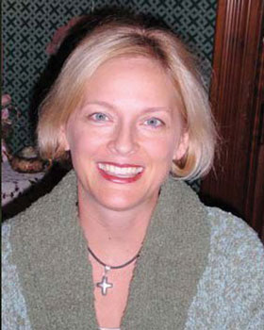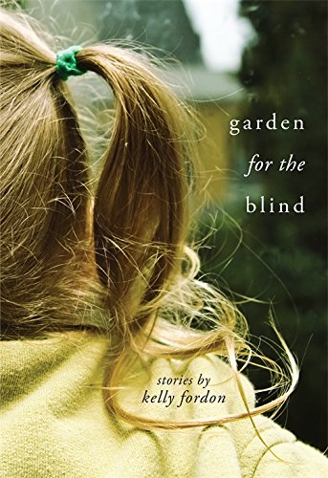
“Garden for the Blind”
On Saturday May 21, 2016
At 1:00pm
At the Alcona County Library
Harrisville Branch
(312 W Main St., Harrisville, MI 48740)
Books will be available from Great Northern Books and Hobby in Oscoda
The 2016 Michigan Notable Books program and tour are made possible thanks to the generous support of the Library of Michigan, the Library of Michigan Foundation, Michigan Department of Education, the Michigan Humanities Council, Meijer, and the Michigan Center for the Book.

