**JOB DESCRIPTION**

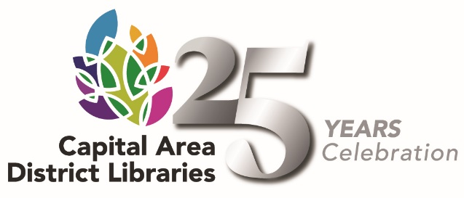

**Position**: Public Services Librarian

**Reports to:** Library Head

**JOB SUMMARY**

Under the supervision of the Library Head provides excellent, friendly and user centered services to community members. Provides day to day direction to staff members to develop a culture of continual improvement. Assists the Library Head in coordinating the activities of staff members, setting goals, assigning duties, and scheduling work hours.

Recommends best practices and procedures for adult and youth services and manages collections to optimize materials based on patron needs.

**DUTIES AND RESPONSIBILITIES**

Assist patrons with their library needs. Provides reader’s advisory assistance and reference assistance. Uses information resources in a variety of formats including print, the internet, etc. to fill requests.

Develops and maintains library collections of books, magazines, audio-visual, and other materials. Selects materials for assigned collections.

Provides one-on-one training in the use of the library, the library catalog, reference materials, computer databases, and the Internet. May teach classes for both the general public and the library staff.

Explains library policies and procedures to the public.

**QUALIFICATIONS**

* Possession of a Master's Degree in Library Science or its equivalent from an ALA accredited program.
* Possession of a Michigan Librarian’s Professional Certificate.
* This is an entry-level position; no previous experience is required.
* Satisfactory completion of a one year probationary period