
In Praise of the Needlewoman:
Embroiderers, Knitters, Lacemakers and Weavers in Art
with Gail Carolyn Sirna
Award-winning embroiderer and regular columnist for Needlepoint Now
Teacher of needlework for over twenty-five years
Recipient of the Lifetime Achievement Award from America’s National Academy of Needle Arts in 2004
http://www.gailsirna.com/
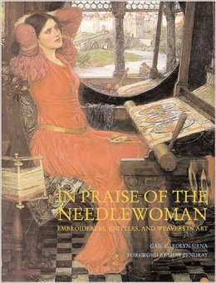

Gail will have a slide presentation along with an exhibit of images.
Thursday, November 14
@ 6:00
Conference room next to Civic Center Library
Please all to register: 586-574-4564

During the months of November and December we will have a display of needlepoint by librarian Ruth Richards in the showcase at the back of our library.

