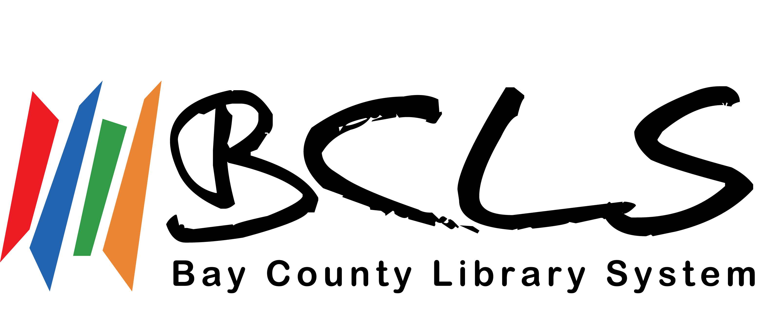
Job Vacancy

Public Services Librarian I, Children’s Department

March 10, 2021

ASSIGNMENT: Public Services Librarian I, Children’s Department

WAGE: 2021 pay range: $21.72/hourly rate at date of hire; 4th step $26.06/hour

HOURS: 40 hours per week, including weekends.

VACATION: After one year - 20 days. Increments in vacation occur at 5, 6, 7, 8 and 9 years of service.

PERSONAL DAYS: 5 days, after successful completion of probation.

SICK: Earned at 1 day per month, accrue until successful completion of probation. Accumulate to 100 days.

RETIREMENT: 401K/457 Retirement options with employer 2% contribution and an additional 2% match.

HEALTH INS: Blue Cross/Blue Shield or a $2,600 deferred compensation annual contribution in lieu of health insurance. (Employee pays 20% of premium.)

DENTAL INS: Blue Cross/Blue Shield dental coverage. (Employee pays 10% of premium.)

LIFE INS: $20,000 life insurance policy on employee.

PROBATION: First 6 months

AVAILABLE: March 29th at the earliest

APPLICATION
DATE: Send cover letter and resume by 5:00 p.m. Wednesday, March 24, 2021

Kevin Ayala, Assistant Director
Bay County Library System
500 Center Avenue
Bay City, MI 48708
kayala@baycountylibrary.org

