**Allegan District Library**

I am the Cataloger at Allegan District Library. We have Vox books and they get checked out a lot. We have a replacement cost of fifty dollars on every book. Some cost more and a few cost less. We keep chargers at our circulation desk. They will charge them before putting them back out. We have stickers on the books asking patrons not to charge it at home. That way we have less odds of someone putting the wrong cords in. We had two books that broke within a year and one just after a year and they were all replaced at no cost to us. One book the speaker fell off, the other two just stopped working and we couldn't get them to charge any more.

I don’t have the information of working with the vendor other than knowing they replaced three of our books for free. From a cataloging perspective they did send me the records for our catalog. I was excited to not have to create records.

**St. Clair County Library Systems**

Way back (2012?) we briefly had Playaways but they did not circulate well.

**Baldwin Library**

We added Vox books a year or two ago and so far they've been sturdier than our Wonderbooks which we've had for like 5 years? I can only surmise it is because the player is centered and not in the corner like the Wonderbooks, but regardless when the book dies we buy a replacement book, and glue the player onto the new book. The patrons don't seem to have a preference of the 2 so I buy both because the selections are different. Vox books are now only sold though Baker and Taylor so you will need an account with them in case you have another vendor. They both have a nice selection of diverse titles.

Playaways circulate quite well here, so much so that we don't order very many CDs at all anymore.

We have decided not to have Tonies or Yotos right now (I was not involved in this decision so can not elucidate).

**Jackson District Library**

We have started incorporating Vox and Wonderbooks into our collection. They are very popular and circulate well. We have even had experiences such as a family letting us know that the grandparents don't speak English very well, and the Wonderbooks were a great way for them to get the experience of reading a book with their grandchildren.

That said, they don't shelve very well. The way these books are designed, there is a small box or device on the inside front cover, but the cover isn't adjusted to fit the device. The creates a situation where the books don't fit nicely on a shelf, especially with other vox/wonderbooks. The front edge of the cover, where the device sits, is wider than the spine. We have solved this problem by using tubs and bins where we can set the books front edge down and the spine facing up. This still uses more space than traditional books, but has served us well as we have the space for special cubes or bins on the floor in the children's area.

**Buchanan District Library**

We are a smaller class III library. We added Wonderbooks and then Voxbooks several years ago, and they are very popular. The Voxbook version of some of our picture books tend to circulate up to 3 times more than the regular print version. They also circulate better than our CDs . We started out with just picture books, but have gotten requests for chapter books, so I just recently purchased some of those.

The players seem to hold up well and they don't need to be charged very often. Because the books don't close all the way, they're harder to organize on a shelf. We have a shelf that you can add dividers slotted into the shelf itself, so we've got them about six inches apart and that helps hold the books up.

The books themselves are just regular hard copy books and wear out a little faster than normal because they don't close all the way, and unfortunately book damage isn't under warranty. But they also circulate much more than regular books, so it's not surprising. We decided to add "do not put in drop box, return inside" stickers on them and tell patrons to please bring them inside to help protect them.

Voxbooks now are sold through Baker and Taylor and that's very convenient for us, and I think they are on sale 12% off through November 16.

Playaway often has a deal if you buy $1000 or more in Wonderbooks or Playaways, you get a percentage off. We never purchase that much at once so we've not taken advantage of it, but it's worth reaching out to customer service to see if there are other deals, or if you are purchasing that much at one time.

**T.A. Cutler Memorial Library**

We have VOX books. They're very popular and hold up well (at least the electronic part...the books are just regular books with paper and cardboard so they handle rough handling, being dropped in snow, etc., as well or poorly as any other book!)

We typically don't send a charger with a book, we just check when they're returned that they don't need to be charged. If they start up and play fine, they're reshelved; if they lag or won't power on, we charge them for a few hours and they're ready to go for months and multiple circulations (I saw a library say they charge every time they're returned; it's totally not necessary).

Storage...they are a little awkward on the shelf, but it isn't a huge deal. We shelve them in a separate spot and just use more dividers and give them more room.

The only "horror" is trying to explain to a parent whose child checked out a few of them that are now misplaced that we really need them to look hard (or contact ex-partner, etc.) because they're $40+ apiece to replace.

We first purchased VOX books in late 2019 or early 2020 and added ten to a dozen each year since. None of them have ever had the electronic portion break or cease to function.

Playaways--we got several as YA audiobooks. I don't think any of them ever circulated. Would not buy again. And definitely wouldn't buy for young kids because you have to have headphones/earbuds/speaker whereas the VOX just plays on a built-in speaker (optionally it has a headphone jack). But your patrons may be different.

We tested Playaway tablets (not sure if you're even considering them, but I know some of them were marketed as readers/audiobooks). One of them stopped taking a charge during the week we previewed the devices. I sent them back, told them there was an issue, never got a satisfactory explanation what caused the problem, and so we never ordered any for the collection--plus they essentially just had demo programs on them, which for the cost I found ridiculous. But since our exposure to them was less than 2 weeks, take my opinion with a large grain of salt.

**Muskegon Library**

I would love to buy some Vox/Wonderbooks, but am wary about cost and how to know if I’m getting the ‘right’ titles.

I looked into Tonies at one point and gave up because I’m almost positive they require an account and my brain broke at how that would work circulating to patrons.

**Brighton District Library**

Hi, Rebecca!  I recently purchased 5 Whazoodles from Playaway as a trial run.  They haven't circulated yet, so I can't really tell you much, other than that I thought they were a good alternative to Tonies/Yotos and they are much smaller than I pictured, so they are nicely contained in a case that's about the size of a Launchpad case.

<https://www.playaway.com/our-products/whazoodle/all>

**Roseville Public Library**

We've recently purchased Tonies to start circulating in our collection. If you are going to be purchasing a large amount of tonies, I highly recommend reaching out to them (<https://us.tonies.com/pages/teacher-and-military-discount>) to receive an educator discount. This will let you purchase the wholesale price. If you're only looking for a couple boxes and figures to get you started, Amazon or Target frequently have pretty good deals. We will be circulating a box individually and then the figures in sets of threes. Both the boxes and sets of figures will be stored in plastic containers secured by locks. They do take quite a bit of time to sync each figure with each box but once that's done, they can be used without a wifi connection.

I know they weren't on your list, but if you do ever decide to add the [Little Tikes Story Dream Machine](https://www.amazon.com/Little-Tikes-Story-Dream-Machine/dp/B0BN5G4G31/ref=sr_1_2?dib=eyJ2IjoiMSJ9.L8td6FZ3eE79Aw25v1xrn6FcmXXLDVQzjBgEj-f_jBUKN9len0IFpABvnk__KaEpoKUZLjhXIq2ifUcaHM9sPmPfMKsLocAasAbPQPBgx6v3jafIYHsE76_Jx7swVydo0GkRLjuYoDhoeCv165ijBpu1iO0VAxSE23f1m1d3oS_6Cd4D9qIuWyr0VWHRuiBOXaI8dOVyDyPT1jcMGMJBPsZu9IMXqMPGHctp6PIDuC8cF0XVj0iIxF4JzHcwa_sVeq3LmzxvGzmrpNu2tCWX4KBE9HTRYspa9pIgAHpv5io.-ru4TpG9GBwRbM9-3Bfo_7zbrcJW8zaFIvARIlYmkWI&dib_tag=se&hvadid=676113260146&hvdev=c&hvlocphy=9016822&hvnetw=g&hvqmt=e&hvrand=18106151779617421619&hvtargid=kwd-2227718110235&hydadcr=26243_13465345&keywords=little+tikes+dream+machine+story&qid=1729635528&sr=8-2) to your collection, I suggest going through Amazon (or any other storefront you can get a good deal on). Little Tikes do not offer any special discounting for educators/librarians   
  
As for Vox Books and Wonderbooks, we place them in plastic hanging bags that go up on a metal revolving rack. They are mixed in with our read-aloud display. They have been pretty popular for us. Every certain number of books will come with a charger. We charge them after they get returned, but patrons can charge them at home if they have one of the general UBC charging cables.

**Oxford Public Library**

We have quite a few Vox books. They are very popular (way more popular than our books with a CD). We have them in the large purple bags that hang. We put them at the beginning of our Media Kit (books with CDs) section so they are easy for patrons to find. We used to interfile them with the other media kits, but that was annoying for patrons who were looking for the Vox format.

They have generally held up very well. The library pages are supposed to plug them in and charge them when the books are returned. We do sometimes have patrons bring one up that is dead and so then we plug it in and charge it.  
  
TLN used to do a bulk order of them for a discount, but now Baker & Taylor sells them, so the last batch I got was from B&T. We have had them for several years now and I think only 1 has had an issue that we had to get rid of it. They are expensive, but I only buy Vox books now for the ‘Media Kit’ section. I am basically phasing out the book with CD format and get rid of a bunch of those each time I weed and not buying new ones in that format.

**White Lake Community Library**

When Lakeland Library Cooperative started offering cooperative wide discounts on VOX books about five years ago, I jumped on the opportunity to have them in our library. They are extremely popular and circulate constantly. Several years ago I was given the opportunity to try a Wonderbook for free and I was really impressed with the quality of the books and have since purchased as many as my meager budget can afford. I vastly prefer the Wonderbooks to the Vox books for the following reasons:

1) The sound quality of the Wonderbooks is far superior to Vox.

2) The Wonderbooks hold a charge much better than Vox. The battery life of the Vox books seemed good at the start, but as they have aged, I have to charge them almost every time they come back to the library. I rarely need to charge my Wonderbooks.

3) I find Wonderbooks easier to operate, the buttons are large, clearly marked, and very easy to use. The buttons on Vox books are very small and not as intuitive.

4) So far, my Wonderbooks have held together better than the Vox. The bindings seem more robust.

5) The lifespan of the Wonderbooks seems much better than Vox. I've had at least four of the audio units on my Vox picture books just completely die. This is unacceptable to me given how expensive they are and for that reason alone, I don't purchase Vox anymore.

**Redford Library (grab images)**

We recently added Tonies and Yotos. The spreadsheet below includes circulation as of September. I think I have spent about $2000 including packaging materials, we stopped buying CD audiobooks two years ago so this was an easy transition for us.

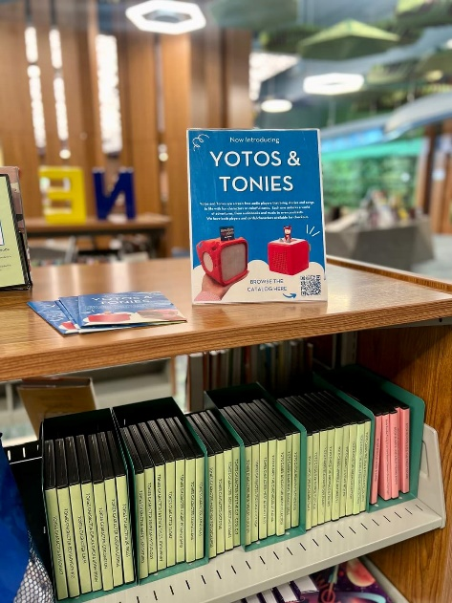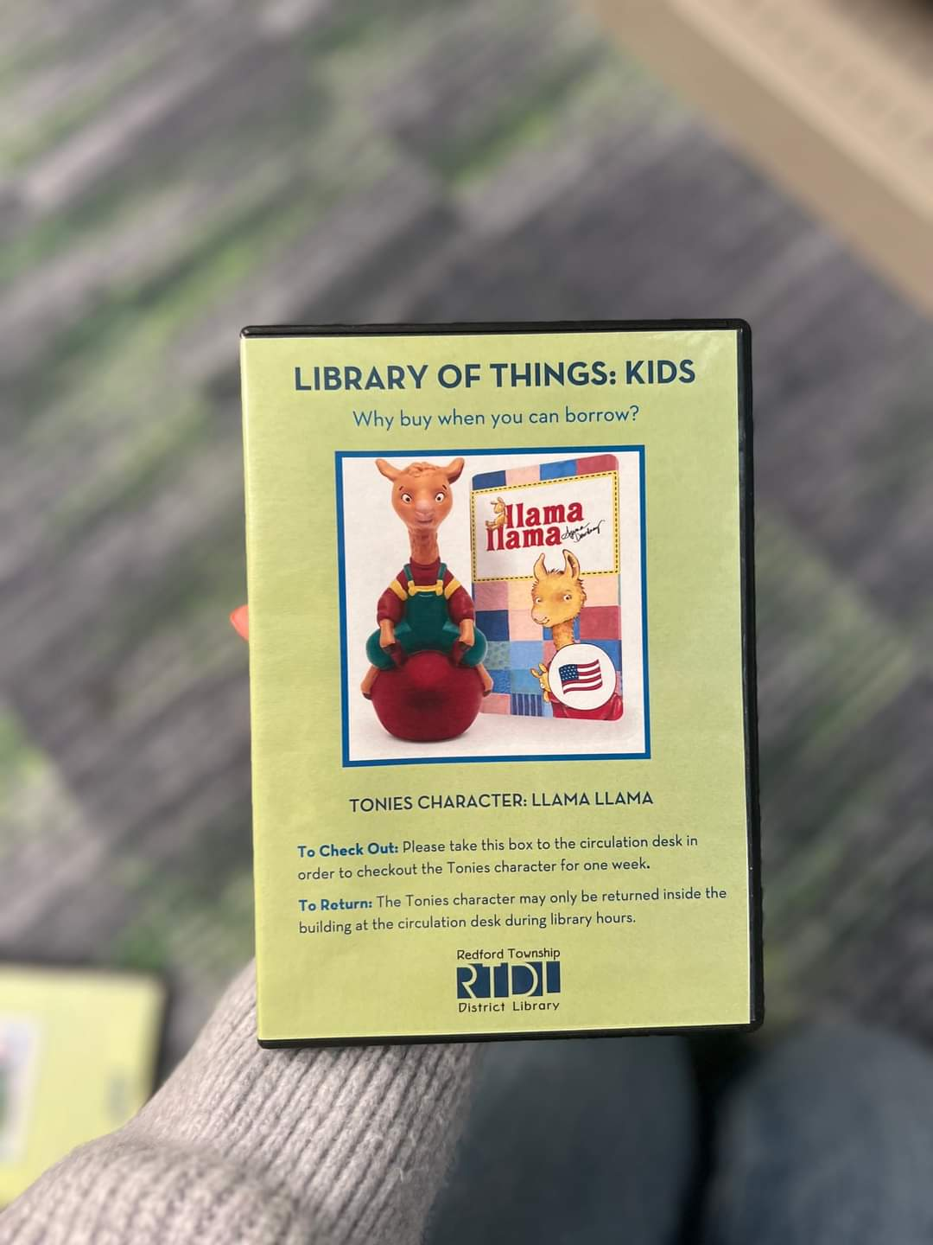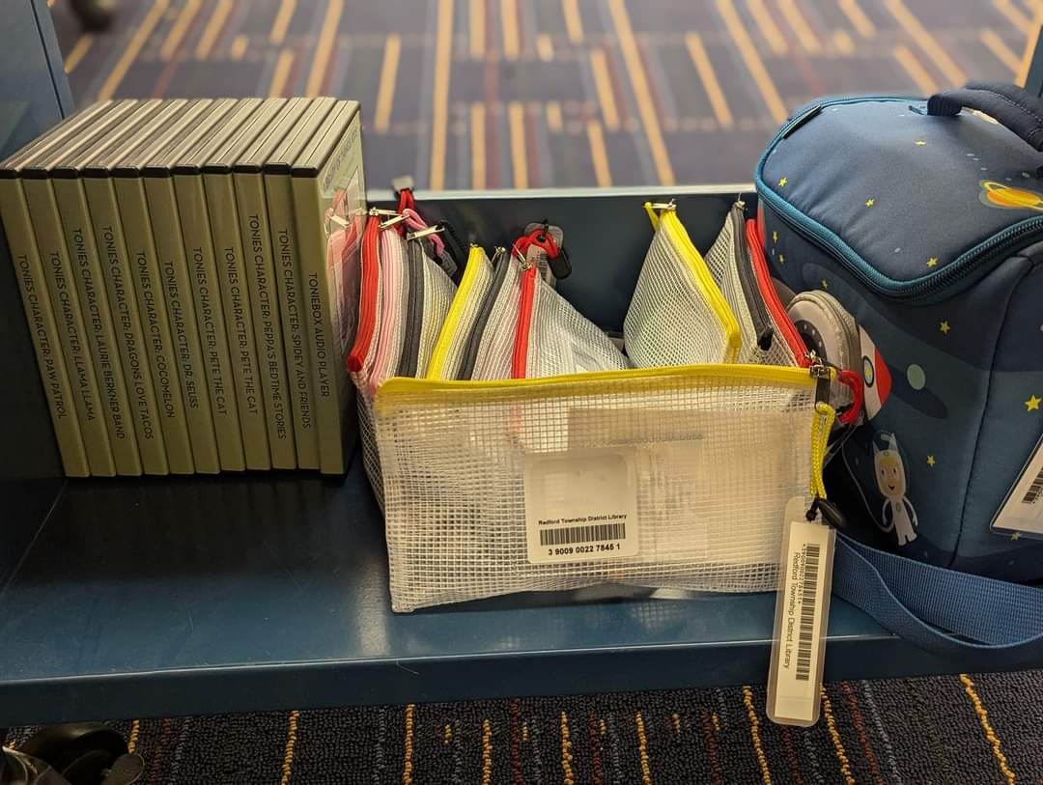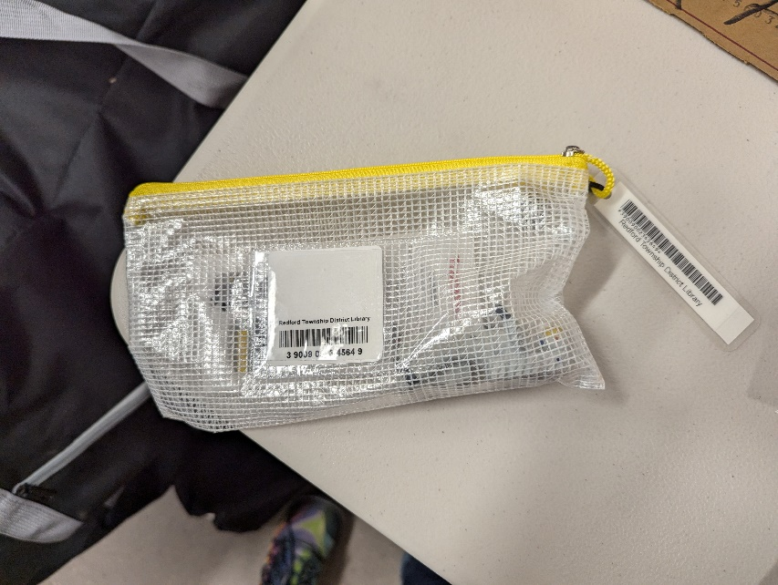

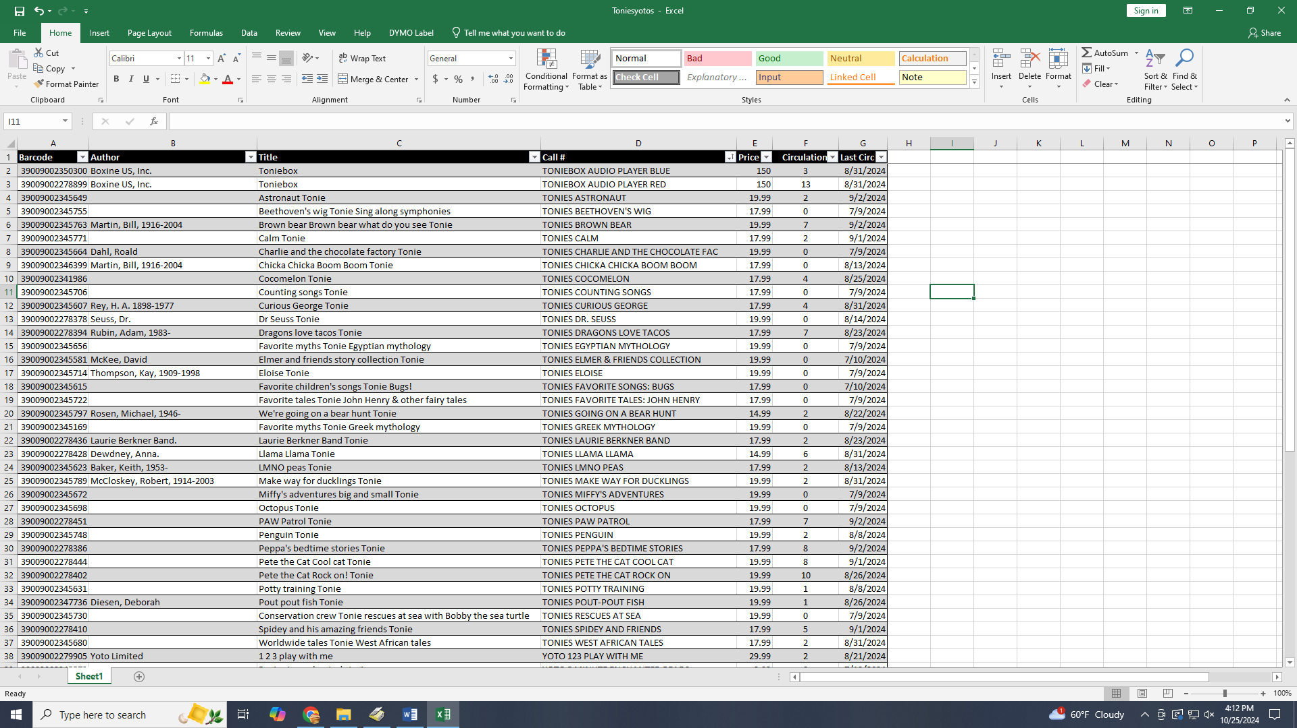

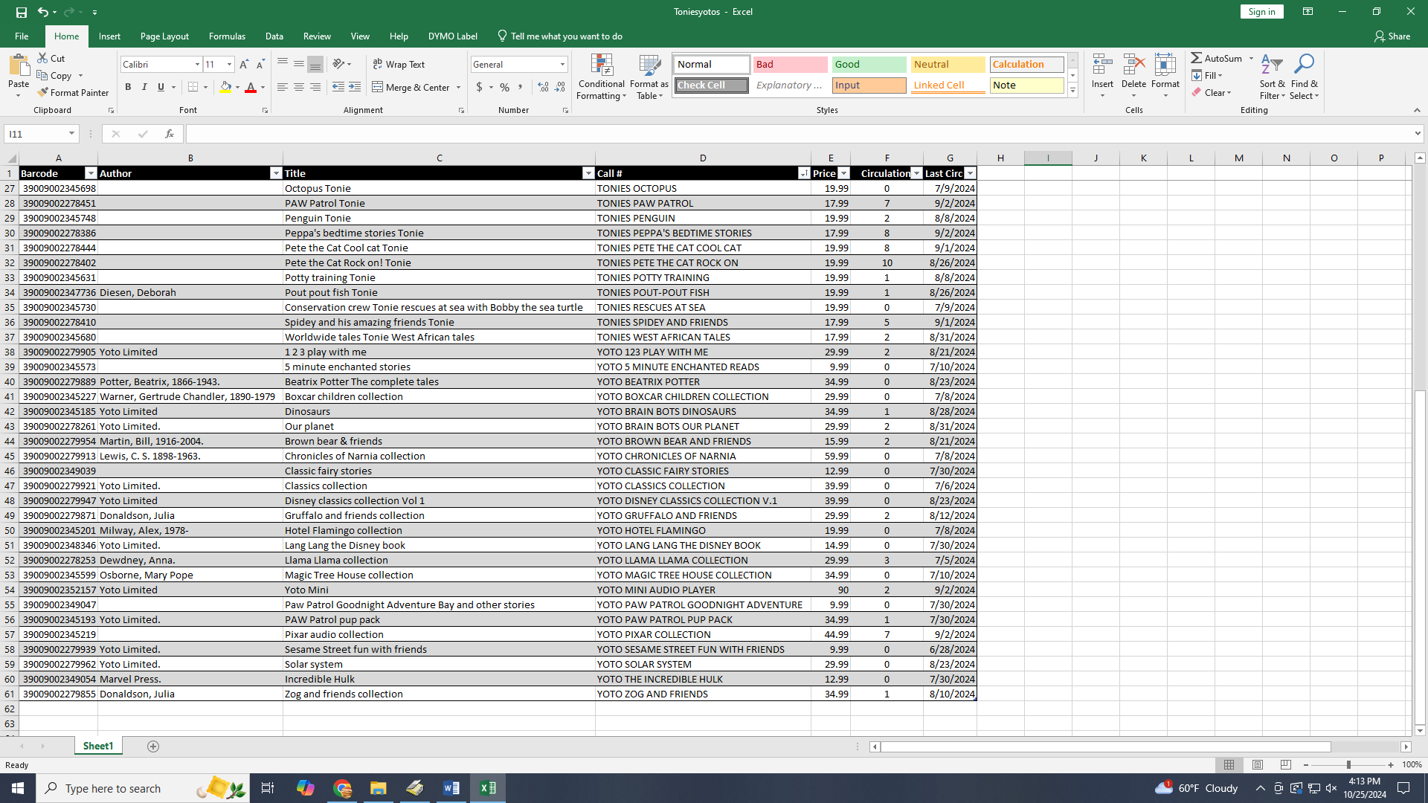

**Rochester Hills Public Library**

I select audiobooks for our community bookmobile. We've switched entirely to Wonderbooks for this vehicle. They've been very durable, and the battery lasts a long time! The main complaint is the format is awkward to shelve. We interfile them with their respective collections. It works out ok as long as there aren't several Wonderbooks together. There are many large print youth fiction Wonderbooks, and those are especially great for struggling readers. My daughter mentioned one in particular had sound effects, which she loved. Our youth department started purchasing them as well. They also have Vox. They've circulated quite well. Once families discover them, they often come on looking for more!

**Parchment Community Library**

Here at Parchment Library over the past 4-5 years we have eliminated our kid’s collection of book read-alongs with CD’s and about half of our Audiobooks.  We still have the more popular audiobooks for kids but the circulation is dwindling.

About 3 years ago we decided to try VOX books.  We liked how they were made, the VOX readers attached to the books are so convenient. As expensive as they were then, and still are, we initially purchased 10 VOX picture books.  Each order comes with 1 or 2 chargers which we keep on the counter in our workroom.  As books are returned, we take them to the back to get re-charged.   They  have been so popular that we’ve had to limit only 1 VOX book per patron per checkout.

In 2023, the Library of Michigan provided a number of VOX books to libraries in Michigan who had responded to a LM request survey.  We responded to that request for 3 different collecitons and  ended up receiving 39 additional VOX books FREE!  That really boosted our VOX collection.  I still plan on purchasing some this year but I limit my order to no more than 5.

I think one thing you have to consider is what you do when a VOX book comes back in horrible shape or worse.  Do you charge the patron the high cost?

We have not had that problem  yet but I’m sure it will happen eventually.