6 Western genre stickers (3 brown/black, 3 orange red) 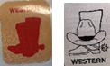


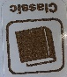
5 boxes of Science Fiction genre stickers (1 purple, 4 red/white)
1 Classic genre stickers
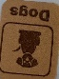
1 box of Sports genre stickers
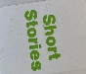
2 boxes of Dogs genre stickers
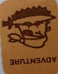
2 boxes of Short Stories genre stickers
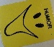
1 box of Adventure genre stickers
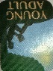
1 box of Humor genre stickers

8 boxes of Young Adult genre stickers


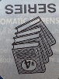
2 rolls of Christian genre stickers
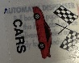
7 boxes of series labels, 4 sheets of Series labels
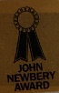
7 boxes of Cars labels
1 box John Newberry award
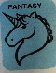
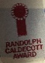
1 box of Randolph Caldecott award
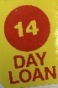
1 box of Fantasy genre stickers
1 box 14 Day loan sticker, 6 rolls of 14 Day loan stickers

