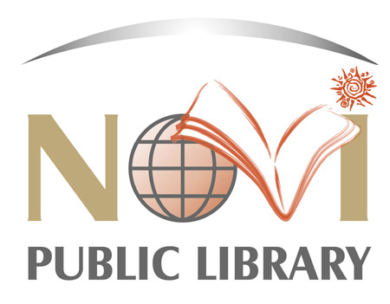

**JOB DESCRIPTION**

***JOB TITLE:* Technology Assistant**

***REPORTS TO:* Technology Supervisor**

The Novi Public Library is a vibrant, fast-paced class six library located within Oakland County. The Library was awarded the "Community Builder Award" in 2021 from the Novi Chamber of Commerce for its innovative approach to reaching its community by introducing the first self-service kiosk in Michigan, called Lakeshore Lending Library. We proudly serve a diverse community with a population of 65,000+. We are committed to serving our guests with exceptional customer service through innovative programming, cutting-edge technology in our iCube Makerspace, and expertly trained staff. In order to meet the needs of our diverse population, we have increased staff awareness and education of Diversity, Equity and Inclusion initiatives through organizational-wide training. We have created NPL @ Your Door, a mail delivery service, to meet the needs of the Novi community who may have less access to the building, and advanced our ongoing commitment to "Inspire, Inform and Include" all individuals who walk through our doors. Join our team!

***PRIMARY DUTIES & RESPONSIBILITIES:***

1. Operates the iCube space and assists guests with the use of the equipment.
2. Designs and implements creative and innovative programming; demonstrates technology outside of the library at community events.
3. Maintains and operates equipment in the iCube Makerspace.
4. Works with volunteers and instructors to develop innovative programs, technology demonstrations outside of the library at community events, and classes in the iCube.
5. Member of technology committees/Virtual Reality.

***OTHER DUTIES & RESPONSIBILITIES:***

1. Working knowledge and understanding of makerspaces.
2. Skill in implementing appropriate programs for guests of all ages; including the identification of outside talent sources.
3. Communicates effectively with guests, co-workers, and professional colleagues.
4. Seeks professional continuing education, both organized and casual, with a commitment to new technology in order for services to remain current and appropriate for staff and guests.
5. Works positively and collaboratively across departments to accomplish department goals.
6. Adapts and responds to multiple priorities, interruptions and demands, and resolves problem situations in a positive manner.
7. Enforces library policies relevant to public use; responds to emergencies and provides support, as needed; acts quickly, exercising good judgment.
8. Performs other duties as assigned.

***JOB QUALIFICATIONS:***

1. High School diploma, GED or higher level of education.
2. Proficient in MS Office, Internet browsers, and other computer related technology.
3. Training experience preferred.
4. Adapts and responds to multiple priorities, interruptions, demands and resolves problem situations in a positive manner.
5. Dedicated to providing positive customer service and public service.
6. Enthusiastic, positive, friendly, self-motivated, creative and approachable.
7. Strong obligation to confidentiality.
8. Strong organizational skills and attention to detail.
9. Excellent verbal, written, and interpersonal communication skills.
10. Values diversity in the workplace and in the community.
11. Ability to speak multiple languages helpful.
12. May require a valid Michigan driver’s license based on assignment.

***WORKING ENVIRONMENT:***

1. Physical mobility, vision, hearing, and manual dexterity essential.
2. Maintain physical condition necessary for sitting, standing, bending, and /or walking for extended periods of time; stooping; crouching; reaching; carrying books or boxes of books; pushing book carts; seeing; keyboarding; using the telephone; lifting, pushing, pulling or carrying objects weighing up to 50 pounds; push or pull with wheeled cart up to 500 pounds; operating assigned equipment; picking up litter; spreading ice melt.
3. Evening, weekend, and some holiday hours are required.

**Hours:** 21 hours per week

* + Monday, 9:30 a.m. – 5 p.m. (w/30-minute unpaid lunch)
  + Tuesday, 4:30 p.m. – 8:30 p.m.
  + Thursday, 4:30 p.m. – 8:30 p.m.
  + Saturday, 11 a.m. – 5 p.m.

**Salary:** $16.50 per hour

**Benefits:** Time benefits (vacation, personal business, and sick) based on a part-time employee formula.

**Application:**

* Only complete application packets (which include a current **Novi Public Library application, resume, and cover letter**) will be considered. Incomplete application packets will not be reviewed.
* NPL applications available at https://novilibrary.applicantpro.com/jobs/
* Employment offer dependent on results of a physical, background check, and in-person job skills testing.
* Send to:
  + **Nicole Williams, HR Specialist**

Novi Public Library

45255 Ten Mile Rd.

Novi, MI 48375

[nwilliams@novilibrary.org](mailto:nwilliams@novilibrary.org)

**Deadline:** Open Until Filled

**Posting:** This position is being posted concurrently for both internal and external candidates.

*This job description is intended to describe the general nature and level of work being performed by a person assigned to this job. They are not to be construed as an exhaustive list of all job duties that may be performed by a person so classified.*