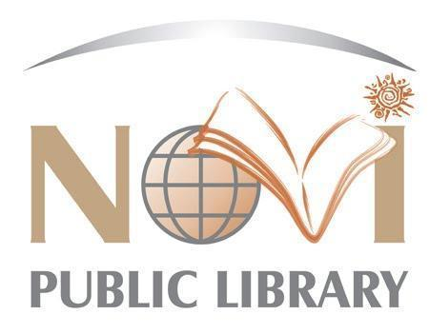

**NOVI PUBLIC LIBRARY**

**JOB DESCRIPTION**

***JOB TITLE:* Community Outreach Librarian – Part-Time**

***REPORTS TO:* Head of Information Services**

Join our team to be the first Community Outreach Librarian at the Novi Public Library! This new position will work directly with community groups all over Novi to improve our programs and services for seniors, small businesses, and residents furthest away from the Library. The Novi Public Library is a vibrant, fast-paced class six library located within Oakland County. The Library was awarded the “Community Builder Award” in 2021 from the Novi Chamber of Commerce for its innovative approach to reaching its community by introducing the first self-service kiosk in Michigan, called Lakeshore Lending Library. We proudly serve a diverse community with a population of 65,000+. As a proud organization within the Novi community, we are committed to serving our guests with exceptional customer service through innovative programming, cutting-edge technology in our iCube Makerspace, and expertly trained staff.

***PRIMARY DUTIES & RESPONSIBILITIES:***

1. Plans, promotes and implements programming services at Lakeshore Park, local senior living facilities and other offsite locations appropriate to the needs of the community.
2. Engages in outreach opportunities within the community; serves as liaison to relevant business associations.
3. Participates in collection development and maintenance keeping within monetary and physical space constraints.
4. Provides readers’ advisory, reference services and computer assistance using a variety of collections, materials and formats.
5. Maintains proficiency with Library databases and digital services, and learns new technology and software.

***OTHER DUTIES & RESPONSIBILITIES:***

1. Adapts and responds to multiple priorities, interruptions and demands, and resolves problem situations in a positive manner.
2. Seeks professional continuing education, both organized and casual, with an air toward keeping services current and appropriate; member of professional development; member of internal and external committees.
3. Communicates effectively with guests, co-workers, and professional colleagues.
4. Enforces library policies relevant to public use; responds to emergencies and provides support, as needed; acts quickly, exercising good judgment.
5. Mentors and trains MLS Librarian Intern; trains and oversees department volunteers.
6. Works positively and collaboratively across departments to accomplish department goals.
7. Performs other duties as assigned.

***JOB QUALIFICATIONS:***

1. MLS from an ALA accredited school.
2. Previous experience working with seniors or in the business community preferred.
3. Library program planning experience preferred.
4. Knowledge of adult and youth literature.
5. Dedicated to public service.
6. Dedicated to providing positive customer service.
7. Enthusiastic, positive, friendly, self-motivated, creative and approachable.
8. Strong obligation to confidentiality.
9. Strong organizational skills and attention to detail.
10. Proficient in MS Office, Internet browsers, and other computer related technology.
11. Excellent verbal, written, and interpersonal communication skills.
12. Values diversity in the workplace and in the community.
13. Ability to speak multiple languages helpful.
14. May require a valid Michigan driver’s license based on assignment.

***WORKING ENVIRONMENT:***

1. Physical mobility, vision, hearing, and manual dexterity essential.
2. Maintain physical condition necessary for sitting, standing, bending, and /or walking for extended periods of time; stooping; crouching; reaching; carrying books or boxes of books; pushing book carts; seeing; keyboarding; using the telephone; lifting, pushing, pulling or carrying objects weighing up to 50 pounds; push or pull with wheeled cart up to 500 pounds; operating assigned equipment; picking up litter; spreading ice melt.
3. Evening, weekend, and some holiday hours are required.

**Hours:** 27 hours per week including evenings and weekends. Suggested schedule:

Monday: 9:30-4

Tuesday: 9:30-4

Wednesday: 1:30-9

Friday/every third Saturday rotation: 9:30-6

**Salary**: $21.90 - $28.47 per hour

**Benefits:** Paid benefit time is offered with this position (sick, vacation, personal business, paid holidays)

**Application:**

* Resume, cover letter and application required.
* NPL applications available at https://novilibrary.applicantpro.com/jobs/
* Send to Nicole Williams, HR Specialist  
  Novi Public Library  
  45255 W Ten Mile Road  
  Novi, Michigan 48375  
  Email: [nwilliams@novilibrary.org](mailto:nwilliams@novilibrary.org)

**Deadline:** Open until filled.

*This job description is intended to describe the general nature and level of work being performed by a person assigned to this job. They are not to be construed as an exhaustive list of all job duties that may be performed by a person so classified.*