
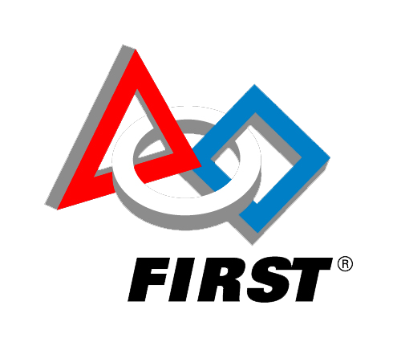
Date and Time of Event (May 6th to May 13th) Free Event to all Ages
Come drive [optional] (Robot Name) and learn about (Team Name), a FIRST Robotics team.
Your local library offers the following STEAM Programs – Come learn how much fun STEAM can be.

Your robot picture here
Name and Location of your library
Robots @ The Libraries

