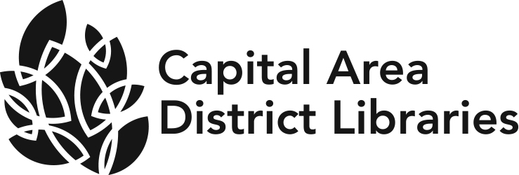
JOB ANNOUNCEMENT

DATE: June 21, 2022

POSITION: Branch Head II

HOURS &LOCATION Okemos Branch, 4321 Okemos Road, Okemos, MI 48864.
OF POSITION: This position is full time.

Join Capital Area District Libraries! CADL supports 13-branches and serves a population of over 240,000 residents located in Ingham County. We are looking for a creative, hardworking person who will help us advance the library’s mission of empowering diverse communities to learn, imagine and connect.

EDUCATION &EXPERIENCE: Possession of a Masters Degree in Library Science from an ALA accredited institute.
Possession of a Librarian’s Permanent Professional Certificate issued by the Library of Michigan.
A minimum of three years satisfactory experience in public library in a supervisory position including or in addition to experience in reference services.

NATURE OF WORK: Under the supervision of the Director, plans and directs the management of the library. Supervises the training, supervision, direction and discipline of circulation and public service staff. Schedules the staffing of the public service desk during all open hours. Assesses community needs, plans, and implements programs, sets service goals, builds, and maintains an appropriate collection with an emphasis on print and electronic reference resources. Enforces library policies and procedures. Communicates with local government on pertinent library issues. Works with community organizations in promoting the library. Performs related duties as needed or assigned.

SALARY RANGE: $67,994-$84,970 annually

BENEFITS: CADL offers full medical, dental, vision and retirement benefits
Paid time off includes vacation, sick, personal and holidays.

DEADLINE TO APPLY: Must be received by 5:00 p.m., Friday, July 08, 2022.

We welcome new staff and the unique contributions each one brings to our library. We strive to hire a wide variety of people from diverse backgrounds to strengthen the service we provide the community. Our goal is to make everyone feel welcome and have a voice at Capital Area District Libraries.
CAPITAL AREA DISTRICT LIBRARIES SYSTEM IS AN EQUAL OPPORTUNITY EMPLOYER.

