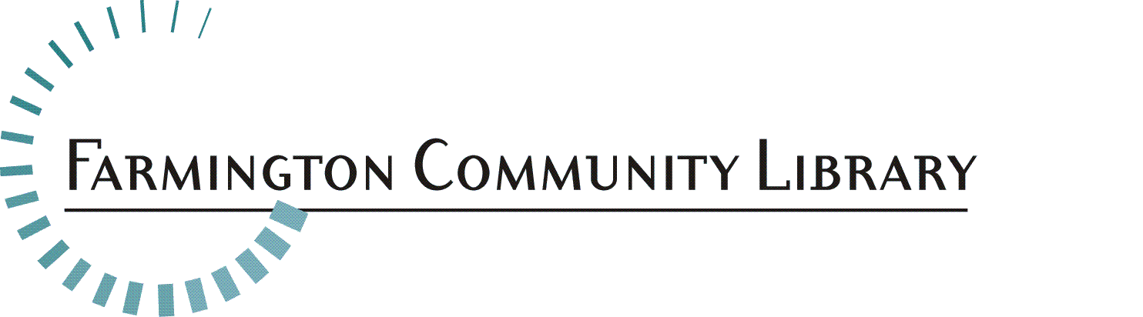

April 28, 2017

The Farmington Community Library is seeking a Part Time Para-Professional in the Children’s Department. Expand your knowledge of libraries, child development and books, materials and resources for ages 0 – 12 working in a diverse community which values education, learning and libraries.

Position Available: Part Time Para-Professional
Children’s Services Department
Main Library

Recommended Salary Range: $14.57 - $20.00 per hour

Part-time Position: 24 hours per week scheduled at either Library Branch, contingent on staff needs. Hours will be scheduled to include evenings, Saturdays and an occasional Sunday.

Fringe Benefits Include: Employer provided vacation, sick, holiday and personal business time, life insurance and 401 (a) Defined Contribution retirement plan. Other voluntary benefits available.

Deadline for Applications: May 15, 2017 by 5:00 p.m.

Interviews for selected candidates: May 23, 2017

Please include your resume, application, www.farmlib.org/application and answers to the following questions:

- Present a detailed outline for a preschool story time for ages 3 – 5 years. Include songs, rhymes, books and activities. Describe what your audience of preschoolers and their adults would experience.

- The Farmington Community Library is a very busy Library that requires staff to multitask and even work in other departments if needed. How would you carry out your job responsibilities, while offering excellent customer service with a positive attitude? Please use your past work experience to give examples highlighting your customer service skills.

Please send your resume to: Elyse Streit, Library Director
Farmington Community Library
32737 West 12 Mile Road
Farmington Hills, MI 48334
Elyse.Streit@farmlib.org

Job Summary:
Under the supervision of Librarians, employees in this classification assist at the public service desks in the Adult Services and Children’s Services Departments. Public services may include reader’s advisory, reference assistance, programming and training on electronic resources.

Essential Duties/Responsibilities:
- Provides quick and accurate reference and reader’s advisory services to the public, using both print and electronic resources. Primarily works with literature, materials and resources for ages 0 – 12 years.
- Assists patrons in learning to use the automated circulation system, electronic resources and the Internet.
- Performs interlibrary loan searches to fulfill patron requests for items not owned. Must be able to search online catalogs of other libraries and initiate MeLCat/OCLC requests.
- Participates in collection development in assigned areas, under the supervision of Librarian. Assignments may include: selection, weeding and preparation of bibliographies.
- Must be familiar with Microsoft Word and Publisher.

Minimum Qualifications:
- Knowledge [such as would be acquired through a baccalaureate educational program or its equivalent in experience, training, or independent study] of basic principles, concepts, and technical methods to carry out limited projects which involve use of specialized, complex problems.
- Personal working or academic knowledge of literature, materials and resources for youth ages 0 – 12 years.
- Some knowledge child development, for ages 0-12 years.
- Excellent understanding of library policies, procedures, philosophy and Public Service Values.
- Ability to work independently, making decisions within the authority ascribed to this position and seeking advice when required.
- Ability to establish and maintain effective working relationships with other staff, supervisors and the public.
- Familiarity with current technology, i.e., general computer literacy, knowledge of the Internet and other electronic sources of information.
- Effective oral and written communication skills.
- Critical thinking skills, which can be applied to successfully answering reference inquiries.
- Knowledge of literature, current events and general information found helpful in resolving reference inquiries.

Physical Activity Requirements:
[Degree of physical demands (strength) usually associated with the essential functions of the job]
Light Work: Exerting up to 20 pounds of force occasionally and/or up to 10 pounds of force frequently and/or a negligible amount of force constantly to move objects. Physical demand requirements are in excess of those for Sedentary Work. Light Work usually requires walking or standing to a significant degree. The type of physical demands usually associated with the essential functions of this classification are: stooping, kneeling, crouching, reaching overhead and horizontally, handling, fingering, feeling, talking, hearing and seeing.

Equipment Commonly Associated with this Job:
Computer, barcode scanner, telephone reception system, microform reader printers, office machinery, among others.

Employee Classification: Part-Time Para-Professional
Part-time employees are regularly scheduled to work 20 – 24 hours per week, with the majority of that time assigned to work at a public service desk. Job requirements remain the same criteria as those for full-time Para-Professional.

