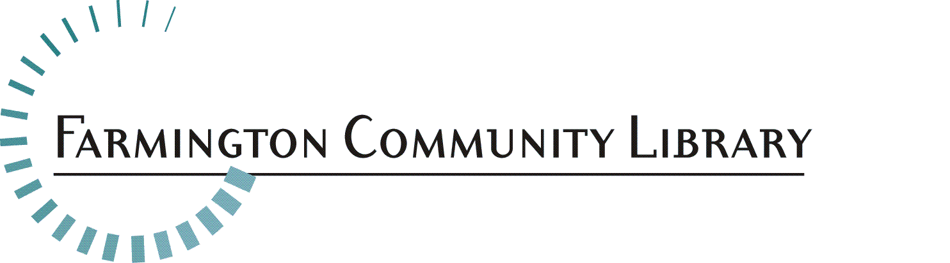

April 28, 2017

The Farmington Community Library is seeking a creative, energetic, ambitious and dedicated part time Children’s Services Librarian. Grow, learn and share knowledge with both peers and patrons in a diverse community which values education, learning and the library. This candidate should have knowledge of best library practices, familiarity of reference materials for children and students, particularly for ages 0 – 12 years, an awareness of children’s current reading, viewing and listening interests and possess technology skills.

Position Available: Part-Time Librarian I Position
Children’s Services Department
Main Library, Farmington Hills

Recommended Salary range: $19.05 - $26.00 per hour

Part-time Position: 24 hours per week scheduled at either Library Branch, contingent on staff needs. Hours will be scheduled to include evenings, Saturdays and an occasional Sunday.

Fringe Benefits Include: Employer provided vacation, sick, holiday and personal business time, life insurance and 401 (a) Defined Contribution retirement plan. Other voluntary benefits available.

Deadline for Applications: May 15, 2017 by 5:00 p.m.

Interviews for selected candidates: May 23, 2017 at the Main Library,32737 West Twelve Mile Road, Farmington Hills.

Please include your cover letter, resume, application http://farmlib.org/application and response to the following questions:

1 .What ideas do you have for services/resources for the Children’s Department that we could realistically implement that would make a significant impact upon the lives of children in our service area?

2. Please include a detailed Preschool Story Time outline.

Please send your information to: Elyse Streit, Library Director
Farmington Community Library
32737 West 12 Mile Road
Farmington Hills, MI 48334
Elyse.Streit@FarmLib.org

Employee Classification: Librarian I Job Summary:
Under the supervision of Senior Librarians and the Branch Head, Librarians beginning their career focus on the Library’s philosophy, policies and procedures as they apply the knowledge gained in library school. Librarians provide public services to children, young adults or adults. Such services include reader’s advisory, reference in print and electronic and programming.

Essential Duties/Responsibilities May Include:
- Provides quick and accurate reference and reader’s advisory services to the public, using both print and electronic resources. Utilizes knowledge of children’s literature materials and resources for ages 0 - 12 years.
- Assists patrons in learning to use the automated circulation system, electronic resources, and the Internet.
- Provides Children’s and/or Adult programming, under the supervision of the Department Head. Children’s staff must become aware of the developmental ages of the child and the activities appropriate for each developmental stage.
- Participates in collection development in assigned areas with responsibility for selection, weeding and promoting use of the collection through creation of bibliographies.
- Becomes familiar with the Library’s Reference Collection and all special collections, thereby serving as a resource for other Information Desk staff.
- May receive a secondary assignment to demonstrate employee understanding and mastery of the Library’s approach to a special collection or service.
- Serves as the Librarian-In-Charge of the building, when assigned. Must be knowledgeable about and able to make decisions in situations dealing with Library security, emergency procedures and conflict resolution.

Minimum Qualifications:
- Master’s Degree in Library and Information Science from a school accredited by the American Library Association or completion by December 2017.
- Application of the basic principles, concepts and methodology of professional librarianship in carrying out basic assignments, operations or procedures.
- Critical thinking skills, as applied to successfully answering reference inquiries.
- Knowledge of Children’s literature, media and resources for ages 0 – 12 years.
- Knowledge of literature, current events and general information found helpful in resolving reference inquiries.
- Effective oral and written communication skills.
- Professional attitude towards providing public library services to patrons.
- Familiarity with current technology, i.e., general computer literacy, knowledge of the Internet, Microsoft Office and other electronic sources of information.
- Ability to establish and maintain effective working relationships with other staff and supervisors.
- Excellent understanding of Library policies, procedures, philosophy and Public Service Values.

Physical Activity Requirements:
[Degree of physical demands (strength) usually associated with the essential functions of the job]
Light Work: Exerting up to 20 pounds of force occasionally, and/or up to 10 pounds of force frequently, and/or a negligible amount of force constantly to move objects. Physical demand requirements are in excess of those for Sedentary Work. Light Work usually requires walking or standing to a significant degree. The type of physical demands usually associated with the essential functions of this classification are: stooping, kneeling, crouching, reaching overhead and horizontally, handling, fingering, feeling, talking, hearing and seeing.

Equipment Commonly Associated with this Job:
Computer equipment plus peripherals, scanner, computer projector, telephone reception system, microform reader printers and office machinery, among others.

