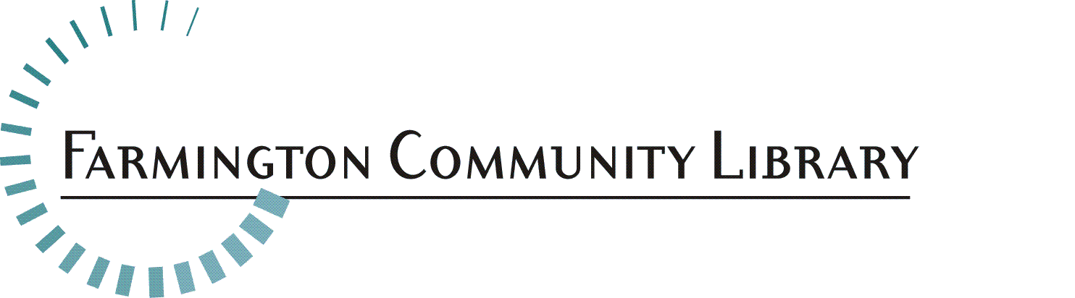

April 28, 2017

The Children’s Department is seeking a Library Science Student for a Professional Internship position. Gain work experience serving a diverse community which values education, learning and libraries.

Position Available: Professional Intern, Children’s Services Department
Main Library

Salary: $12.48 per hour

Part-time Position: 12 – 19 hours per week, including evenings and weekends

Fringe Benefits: None

Deadline for Applications: May 15, 2017 by 5:00 p.m.

Please respond with a cover letter, resume and application. Application is available at www.farmlib.org/application .

Send your information to: Diane Serresseque
Executive Assistant
Farmington Community Library
32737 West 12 Mile Road
Farmington Hills, MI 48334
Diane.Serresseque@farmlib.org

General Information
This position offers paid, practical library experience for students currently enrolled in a School of Information/Library Master’s program. Students are responsible for providing evidence of enrollment and satisfactory progress toward completion of their degree.

Essential Duties/Responsibilities:
- Provides information, reference service and readers’ advisory service to patrons seeking materials, services and resources for children ages 0 – 12 years in person, over the phone and via email
- Performs collection maintenance duties as assigned
- Develops, plans, implements or assists with library programs for all ages as appropriate
- Attends meetings as appropriate
- Assists patrons on public computers
- Other tasks as assigned

Minimum Qualifications:
- Current enrollment in a School of Information/Library Science Master’s program
- Successful and relevant work experience in a public service setting
- Ability to work successfully with divers e patrons of all ages, ethnicities and backgrounds
- Positive attitude and approach to problem-solving, customer service and public service
- Excellent communication and interpersonal skills
- Some knowledge of child development
- Some knowledge of books and audio-visual materials for youth
- Working knowledge of Microsoft Word

Preferred Qualifications
- Experience working in a public library
- Experience or class work in children’s services and/or children’s literature

