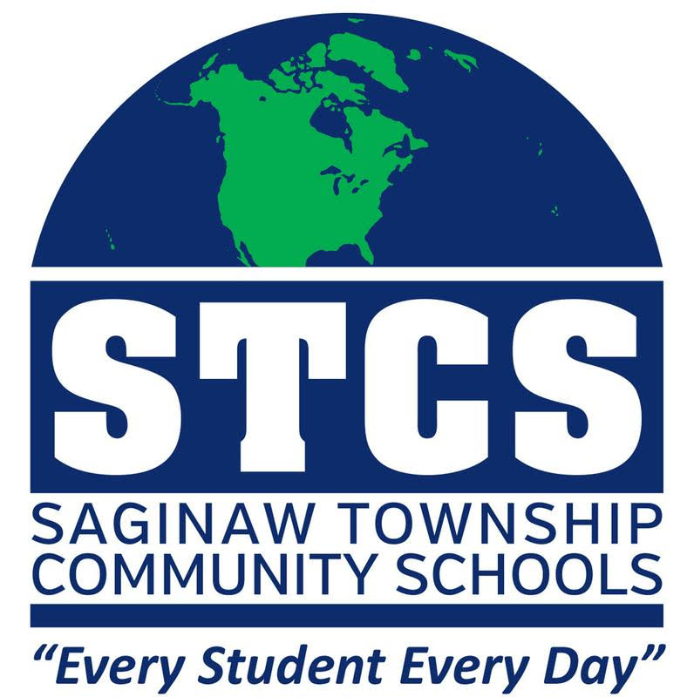

A member of the Mid-Michigan

Area Public Schools Consortium

**DISTRICT LIBRARY MEDIA SPECIALIST**

**Saginaw Township Community Schools**

**DISTRICT OVERVIEW**

Saginaw Township Schools is located in a multi-cultural and vibrant community in mid-Michigan. We are proud to have ‘National School to Watch’ and ‘Blue Ribbon Award’ winning schools.

**POSITION OVERVIEW**

This District Library Media Specialist works as the Library Specialist for the Saginaw Township School district to provide students and staff with an enriched library environment that fosters intellectual growth and real-world skills. This position will spend the majority of time between White Pine Middle School and Heritage High School and includes oversight of elementary school Library Media Assistants.

Please note, the incumbent’s retirement period is still TBD (within 2 years). The selected applicant will work with the incumbent until they retire, creating two certified Library Media Specialists. The starting date is fluid (either the 2022-2023 or 2023-2024 school year), based on the selected applicant’s availability.

**EXAMPLES OF DUTIES:**

Duties may include, but are not necessarily limited to:

* Establish processes and procedures for selection, circulation and resource sharing to assure appropriate media and text resources for students and staff.
* Prepare and administer the district library program budget to support program goals
* Supervise support staff, which may include educational assistants and volunteers
* Champions equity, access, and intellectual freedom for users within the physical space and beyond, including providing 24/7 access to the online library catalog; digital and audio books; and various information resources
* Fosters exploration, discovery, creation, and innovation in a growth mindset
* Supports learners’ success by guiding them to read for understanding, breadth, and pleasure.
* Teaches all members of the learning community to engage with and use information in a global society
* Develops and supports the schools’ and the library’s mission, strategic plan, and policies
* Partners with teachers to design curriculum that integrate elements information literacy, creativity, innovation and the active use of library materials
* Manages the staff, budget, and the physical and virtual spaces of the school libraries
* Evaluates, introduces, and models emerging technologies for the learning community and uses technology tools to supplement school resources
* Participates as an active leader of the local learning community, building and maintaining relationships with external organizations and stakeholders
* Coordinates book clubs
* Collaborate with internal school and external public groups
* Process computer work tickets
* Teaches information literacy skills to build proficiency for student-driver research
* Knowledge of various literacy explorations – foundational, digital, media, news and computational
* Daily, in-person attendance
* Other duties as assigned

**MINIMUM QUALIFICATIONS:**

* Valid Michigan Teaching certificate with appropriate certification (ND), K-12 certification preferred
* Master’s Degree in Library Science from a program accredited by the American Library Association or a Master’s level program in Library and Information Studies
* Follett and/or Destiny experience preferred
* Knowledge of reading strategies desired
* Ability to read, analyze and interpret technical procedures, governmental regulations, professional journals
* Skilled in the use of library software and data entry
* Ability to work effectively and positively with staff, students and the general public
* Ability to assume responsibility and maintain confidentiality
* Ability to prioritize, multi-task and manage library tasks for two buildings efficiently

**MENTAL/PHYSICAL REQUIREMENTS:**

* Maintain emotional control under stress
* Ability to use sound judgment; tact and courtesy in a variety of situations
* Meet multiple demands from several people and interact with students and staff
* Daily, in-person attendance required
* Work with frequent interruptions
* Repetitive hand motions
* Prolonged use of computer
* Occasional lifting or pushing of up to 50 pounds such as boxes of books and AV carts
* Vision requirements include close up reading such as needed for handwritten or typed material, ability to adjust focus and depth perception.
* Standing, walking sitting, stooping, bending and kneeling
* Reasonable accommodations may be made to enable individuals with disabilities to perform the essential functions.

**WORK ENVIRONMENT:**

Primarily an indoor work environment, alternating between two school buildings. The employee is frequently required to interact with students and staff.

**COMPENSATION & BENEFITS:**  
STEA Agreement, provides that the 2022-2023 compensation starts at $42,548 Bachelor's Degree (no previous teaching experience); $49,794 Master Degree, (no previous teaching experience).  The parties' collective bargaining agreement is through July 31, 2024, with a wage re-opener in 2023-2024 school year. Standard employee benefits.

Pursuant to Public Act 68 of 1993 and Public Act 83 of 1995, selected new employees shall submit to fingerprints and a criminal background check at the employee's expense.

It is the policy of STCS that the district will not discriminate against any person based on sex (including pregnancy, gender identity or sexual orientation), race, color, national origin, religion, height, weight, marital status, disability, handicap or age in its programs, services or activities. The following person has been designated to handle inquiries regarding the nondiscrimination policies: Director of Human Resources & Labor Relations, STCS, PO Box 6278, 3465 N. Center Rd, Saginaw, MI 48608. Phone 989-797-1800. www.stcs.org