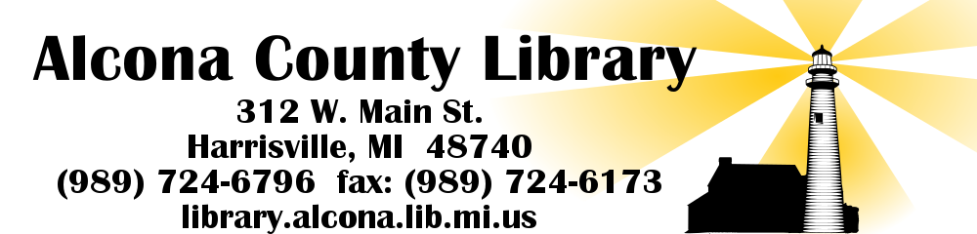

APPLICATIONS BEING ACCEPTED FOR

PART-TIME
CHILDREN’S SPECIALIST

Duties include but not limited to:
Children’s programming
Selecting materials for Juvenile Collection
Limited Reference
Circulation desk duties
Limited Computer Instruction
Requires light work lifting and carrying.
Other assigned duties

Associates Degree and/or related experience Required

25 hours per week

Application and Job Description available at Circulation Desk and online at library.alcona.lib.mi.us

Send application and resume to:
director@alcona.lib.mi.us (with subject
“Children’s Specialist) OR
Denise Bearre
Alcona County Library
312 W. Main.
Harrisville, MI 48740

Applications accepted until 5:30 p.m. Friday October 11, 2019.

