We are circulating our Immersive Reality Kits already, however we got one set of duplicates so we only have 3 instead of 4. We had extra goggles that were more durable than the ones provided, the ones we have are plastic. We put the book and goggles in a hanging bag, with the book, goggles, and bag color coded. On the bag it has a picture of everything in the bag, as well as a brief description of Immersive Reality.   
______________________________________________________________

We have about 8 in total I believe and they go out with their box goggles, which if we have to replace are only $8 is what I was told. We just rubber band them to the book they go to. They currently sit between two book ends to hold them all up. It works alright, we have them right next to our Vox Books. Hope that helps.

_______________________________________________________________

We just rubber band a pair of goggles to each book, and shelve them together (they have their own unique location, near our regular VOX collection).  Some of the original goggles are a little worn, but we haven't had to replace any yet.  Replacements are only something like $8, if I'm not mistaken, so I'm not too worried about them anyway.

____________________________________________________________  
  
I purchased these for our library a few years ago when they first came out, and we ended up labeling each goggle with its own Item Number. The patron can check out as many IR books as they want, and then 1 pair (or more if they choose) of goggles. The outer box they have them in is pretty sturdy and as far as I know, we have yet to lose any goggles to damage or wear and tear! We put the Item Number on that outer box.   
___________________________________________________________________________________

We bought these [kit bags from Amazon](https://www.amazon.com/Hanging-Storage-12-5-inch-Classroom-Pharmacy/dp/B079H5LNHZ/ref=sr_1_4?crid=12M98YPHC1OH3&keywords=monaco+hanging+storage+bag&qid=1692118139&sprefix=monaco+hanging+storage+bag%2Caps%2C105&sr=8-4) to circulate the book with the goggles as a kit. They’re definitely not as nice as the ones from traditional library vendors, but are vastly less expensive, and are fine. I’d recommend [sizing up a bit](https://www.amazon.com/Monaco-Hanging-Polyethylene-Classroom-Pharmacy/dp/B0042SYO6C/ref=sr_1_6?crid=12M98YPHC1OH3&keywords=monaco+hanging+storage+bag&qid=1692118283&sprefix=monaco+hanging+storage+bag%2Caps%2C105&sr=8-6), though – the ones we bought work, but the fit is a little tighter than would be ideal.  
___________________________________________________________________

We had some drawstring bags that are made with a netted material that work great with our VOX books. They are so fun! Staff enjoyed them.

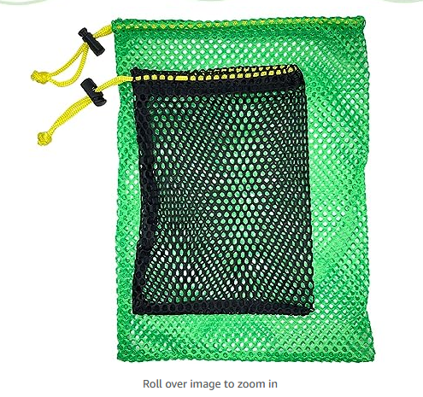

___________________________________________________________________  
  
We are using velcro to keep the goggles to the books and then they can flatten the books while still able to read them. I have attached pictures of what we've done. So far they have circulated well.

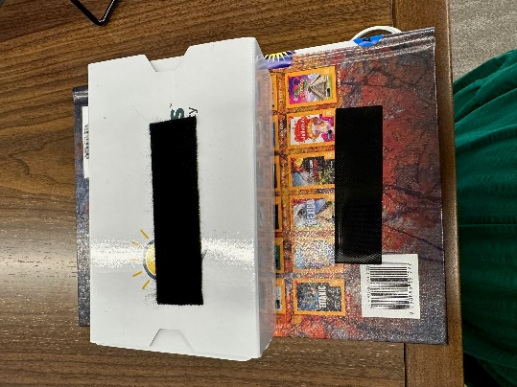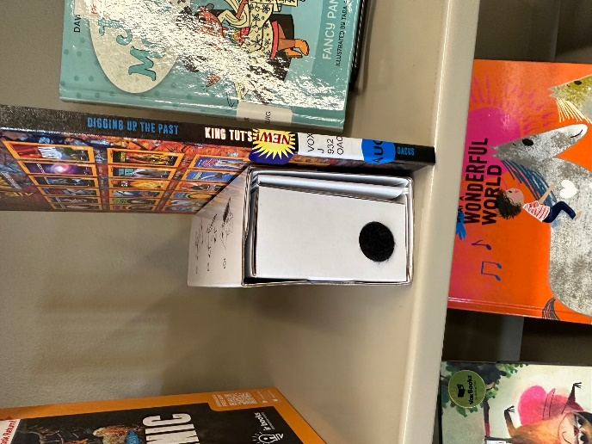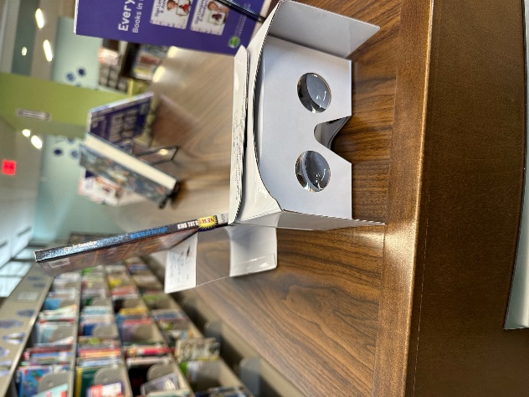

_________________________________________________________________________________  
  
We have had them for just over a year and they are cataloged separately from the books.  That way a family can check out multiple books and only one set of goggles.  We have not had problems with them getting damaged or lost.

We recently received these books from Library of Michigan also. Our department is processing them by using HangUp Bags from Demco. The book and goggles fit in nicely. We used style 105 for the size option. Here's the link: <https://www.demco.com/deluxe-monaco-hangup-reg-bags>  
____________________________________________________  
  
We put a sticker on the book saying they come with goggles, and then keep the goggles at the circ desk.  So far, it has worked for us.  I also put a check in note so that we ensure the goggles are retuned with the books.  We also got these this summer, but so far, this system seems to work for us.

____________________________________________________________________________________  
  
We combined all 4 of the books into one set with one pair of goggles and called it an Immersive reality books kit. We figured the cardboard goggles can be easily damaged and it would be easier to replace with the extra set than order a new pair.

We placed them in this box: <https://www.amazon.com/gp/product/B09JQ5NHLB/ref=ppx_yo_dt_b_asin_title_o01_s00?ie=UTF8&psc=1>