Huntington Woods Public Library

Youth Services Librarian – Part Time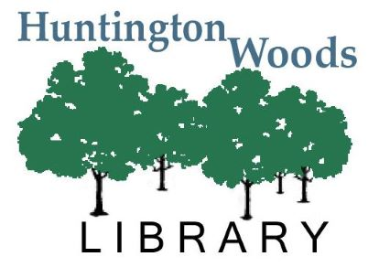

Library Overview

The Huntington Woods Public Library is a Class III library serving approximately 11,000 residents in Huntington Woods and Pleasant Ridge. We are located at 26415 Scotia Road in Huntington Woods and we share a border with the Detroit Zoo. The library is in the middle of the HW community, sharing a parking lot with the Gillham Rec Center and an elementary school, making us a very walkable and bikeable library. We belong to The Library Network (TLN) consortium and are a municipal library.

Position Summary

Under the direct supervision of the Youth Services Coordinator, the Youth Services Librarian is responsible for providing reference, reader’s advisory, programming and collection management services to the public. This is an hourly position without benefits and is not eligible for overtime under FLSA guidelines.

The ideal candidate will possess the following qualifications:

* Master’s Degree from an ALA-accredited library science program, or working toward one.
* Knowledge of public library service as well as current trends in library service to children and youth.
* Ability to plan and execute an effective social media presence for the library.
* Strong online search skills.
* Excellent rapport with children and youth as demonstrated by previous paid and volunteer positions.
* A commitment to diversity and equity in all areas of library work.
* Excellent organizational and planning skills.

Hours and Compensation

* 20-25 hours per week, including some evenings and weekends.
* $21/hour with annual raises.
* No benefits included.

Job Duties

An employee in this position may be called upon to do any or all of the following duties. These examples are not exhaustive and the employee may be called upon to perform duties not listed here.

* Provide reference and reader’s advisory to children, youth, and their parents.
* Collection development of materials for babies through high school students.
* Plan and lead programming for babies through teens.
* Assist with social media promotion of children’s and teen events.
* Flexibility in scheduling is required as this job requires evenings and weekends, including Sundays.
* Participate in both online and in-person professional development and training sessions, as needed.
* Other tasks as needed.

To Apply

Email resume and cover letter and answers to the questions below to Deb Hemmye at [dhemmye@hwoodslib.org](mailto:dhemmye@hwoodslib.org). Please answer the following questions in 300 words or less:

1. Aside from book challenges, what do you think are the most important challenges facing children’s and youth programming today?
2. What opportunities do you see for children’s and youth programming in the next five years?
3. List a picture book, a J Fiction book, and a YA book and tell why you like each.

**This position closes Friday, May 5th at 5:00 p.m.**