English Conversation Group – Pets
Brainstorm some words or phrases associated with pets and caring for a pet.

Vocabulary
chaos – confusion
breeder-a person who raises animals
shelter – building serving as a temporary residence, as for homeless persons or animals
adopt – to take and rear as one’s own
in favor (of someone or something) – approving or supporting
puppy mill – A business owned by a dog breeder who breeds too many dogs not taking care of the quality or health of the puppies produced.in theory – according to a theory
stray cat- ownerless cat found wandering
“dog person” or “cat person” – A person who only prefers dogs or cats.
mutt – mixed breed. Not a purebred dog.

Read aloud:
A furry friend can bring a lot of joy into your life. Or, it can bring a lot of chaos. It all depends on what kind of animal you own.
How can you make sure that you’ll end up with a perfect puppy or kitten? Some people prefer to purchase a pet from a pet store or breeder, so they can have more control over the type of animal and where it comes from. But there are a lot of great dogs and cats in need of homes in animal shelters. And, adopting a pet from a shelter often means saving its life. Hear Amy and Jason talk about adopting pets.

Dialogue: Find a partner and practice. Switch partners and practice again.

Jason: I’m generally in favor of adopting animals from shelters as opposed to getting them from a puppy mill or a pet store.
Amy: Me, too.
Jason: There are too many animals who need a home. There’s thousands of stray cats in every city, so if you can cut down that number a little bit by providing them with a home, it seems like a good thing to do.
Amy: It’s so true. I got my dog from a shelter and she’s just the best dog!
Jason: My aunt is a real “dog person” and always gets her dogs from a breeder because she loves beagles. Unless you’re going to enter your animal in dog shows or use them for hunting, I don’t think you need a purebred dog.
Amy: I guess some people are willing to spend a lot of money on the breed of dog they prefer. But, sometimes you can find purebred dogs at a shelter.
Comprehension:
Who got their dog from a shelter?
Where can you sometimes find purebred dogs?
What kind of dog does Jason’s aunt love?
Discussion Questions: find a partner and ask each other the following questions.
Do you own a pet or did you ever own a pet?
Are you a dog person or a cat person?
Is it common in your country for people to own pets?
Have you ever adopted a pet from an animal shelter?
Do you think it’s better to adopt a pet or buy one from a pet store or a breeder?
What type of animal makes a good pet for children?
Do you think it is good for children to have a pet? Why or why not?
Do you think it’s better to get a puppy or kitten, or wait and get a pet when it’s a little older?
Are pets allowed on public transportation and in restaurants in your home country?
It is said that sometimes dogs and their owners resemble each other. Do you think this is true?
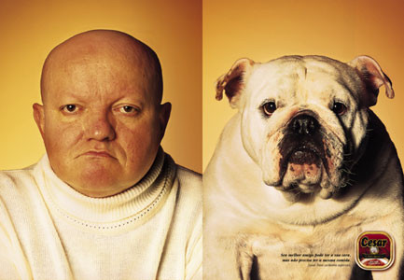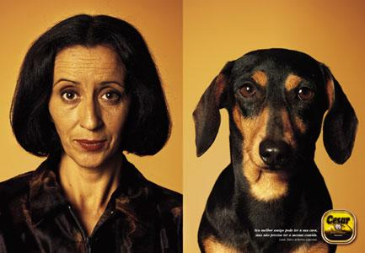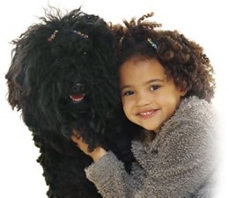

Idiom Meaning Example Sentence
Doggy bag | To have a restaurant wrap up your leftovers as if you were taking them home for your dog. | “I can’t eat all of this. May I have a doggy bag, please?”
His bark is worse than his bite. | Someone’s words are more harsh than their actions. | “Mrs. Smith says she’ll call the police if we step on her lawn, but her bark is worse than her bite.”
A cat has nine lives. | Cats can survive things that are severe enough to kill them. | “I think my cat used up one of her nine lives when she survived being hit by that car.”

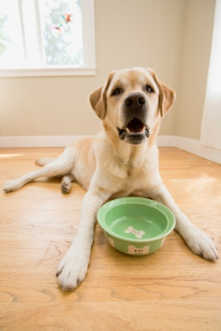
Rhyme: Have one person read aloud, then all read together.
Oh where, oh where has my little dog gone?
Oh where, oh where can he be?
With his ears cut short and his tail cut long,
Oh where, oh where can he be?

