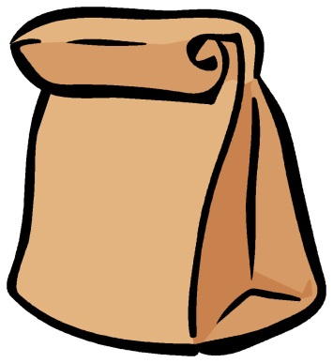

You don’t know the title.
You don’t know the author.
You don’t even
know what
it looks like!

