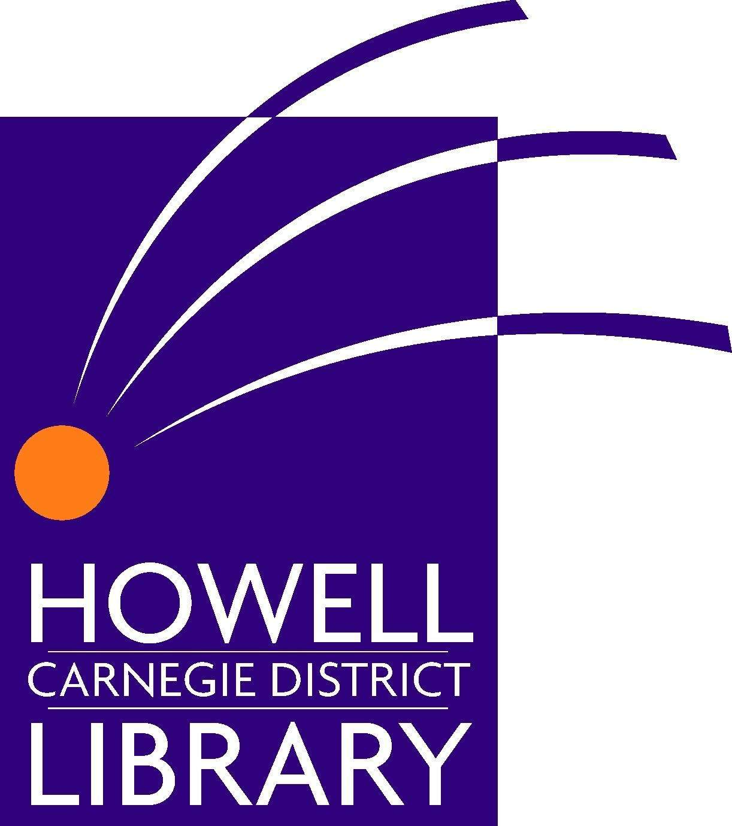
LIBRARARIAN

The historic Howell Carnegie District Library (HCDL) has a full-time position available for an enthusiastic, creative and technology-savvy librarian with excellent customer service skills to join the Adult Services Team. We are looking for a self-motivated individual who is skilled at readers’ advisory and comfortable with teaching patrons to use a broad array of computer software and mobile devices.

Qualifications Required:
- MLS from an ALA accredited institution
- Minimum of one year of professional or pre-professional library experience
- Ability to use Microsoft Office Suite
- Ability to bend, stoop, crouch and reach, pulling & carrying objects up to 50 lbs

Special Preference given for:
- Experience with making effective presentations to local businesses and groups
- Experience with planning, implementing and evaluating programming

Knowledge, Skills and Abilities:
- Possess a winning attitude that is positive, upbeat, focused
- Takes initiative - seeking opportunities, taking intelligent risks
- Desire and ability to provide excellent customer service
- Knowledge of materials and subjects of interest to adults and the ability to elect appropriate reading materials, especially those related to business
- Knowledge of reference tools and procedures
- Demonstrated computer aptitude and familiarity with technological innovations that affect libraries and library users
- Ability to build relationships with community and business groups
- Excellent planning skills

Duties include but are not limited to:
- Assists library patrons with material selection, reader’s advisory and reference and technology questions
- Selects material for purchase, weeds and develops assigned collection areas
- Attends and participates in local business meetings, committees and events
- Initiates, plans, and conducts a variety of programs and activities both in the library and outside
- Acts as Department Head in his/her absence

Wages:
$31,346 – $40,768 beginning salary depending on qualifications, attractive benefit package available. The Howell Carnegie District Library is an equal opportunity employer.

Applications will be accepted until the position is filled, but those received by February 1, 2016 will receive first consideration. Interested individuals should forward a cover letter which specifically addresses the position requirements, a resume and three references with contact information, including email addresses.

Email resume to employment@howelllibrary.org. For more information call Diane McKee at 517-546-0720 x 114.
1-7-16

