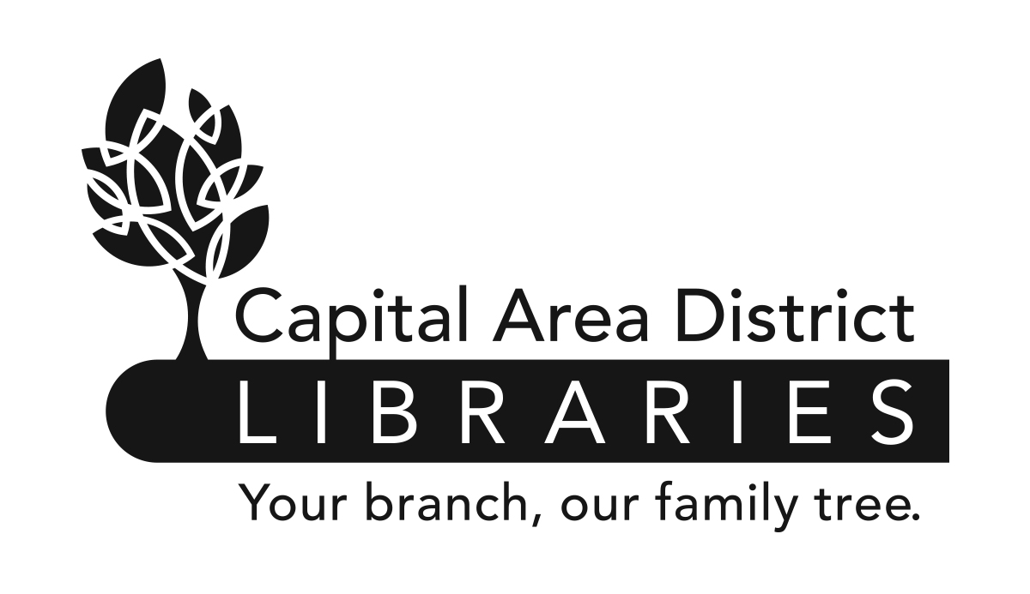

JOB ANNOUNCEMENT

CAPITAL AREA DISTRICT LIBRARIES

PO Box 40719, Lansing, MI 48901-7919 (517) 367-6300

DATE: October 25, 2013

POSITION: LOCAL HISTORY LIBRARIAN

HOURS & Downtown Lansing Branch, 401 S. Capitol Avenue, Lansing, MI
LOCATION OF 40 hours/week. Will include evenings and weekends.
EMPLOYMENT:

Capital Area District Libraries (CADL) provides library services to our local communities seven days per week. All positions will require some evening and weekend hours, including Sundays. While this position is currently assigned at the above location, CADL reserves the right to require all employees to be available for assignments at any CADL location.

EDUCATION & Possession of a Master’s Degree in Library Science or its
EXPERIENCE: equivalent from an ALA accredited institution. Possession of a Michigan Librarian’s Professional Certificate. Completed a course of study in Archival Studies at an accredited institution. Certification as an Archivist is desired but not a requirement.

NATURE OF Under the supervision of the Reference Head, supervises the WORK: operation of the Forest Parke Memorial Library and the Local
History Collections. Responsible for local history; reference, conservation and preservation of materials at all CADL Branches. Develops and maintains assigned library collections; provides one-on-one and group training for library patrons and staff. Also performs professional work in reference, collection development, reader's advisory service, acquisitions, or other specific fields. May supervise the work of volunteers and support staff.

SALARY: $44,720- $55,889 annually (plus benefits)

DEADLINE TO Must be received by 5:00 p.m. Monday, November 25, 2013.
APPLY:

FOR DETAILS Contact the Capital Area District Libraries, 401 S.
AND/OR Capitol Avenue, Lansing, Michigan, Monday-Friday,
APPLICATION: 9am-5pm, (517) 367-6300 or visit www.cadl.org/jobs

Please send a completed Capital Area District Libraries Application* to: Capital Area
District Libraries, Attn: Human Resources, PO Box 40719, Lansing, MI 48901-7919.

*All applications for employment must be made on the Capital Area District Libraries application form and completed in full. Resumes will not be accepted or evaluated in lieu of application. All applicants must meet the minimum and special eligibility requirements, as listed on this job announcement, for the vacancy and file a timely application in order to be considered. Separate application forms must be submitted for each position for which an applicant wishes to apply.

CAPITAL AREA DISTRICT LIBRARIES SYSTEM
IS AN EQUAL OPPORTUNITY EMPLOYER.

